**Team 11**

**Assignment 2**

Vaishali Lambe

Rijuta Wagh

Ankur Muley

**Part 1: Data wrangling and exploratory data analysis**

**Data Download and pre-processing (Accepted Loan Data):**

**Script Name: DataExtraction.ipynb/dataextraction1.py**

**Downloads data from**

<https://www.lendingclub.com/info/download-data.action>

As sign in require lot of inputs to provide, didn’t create the login. Directly downloading data from the url. Created one data set from multiple .csv files as Accpted_LoanData.csv

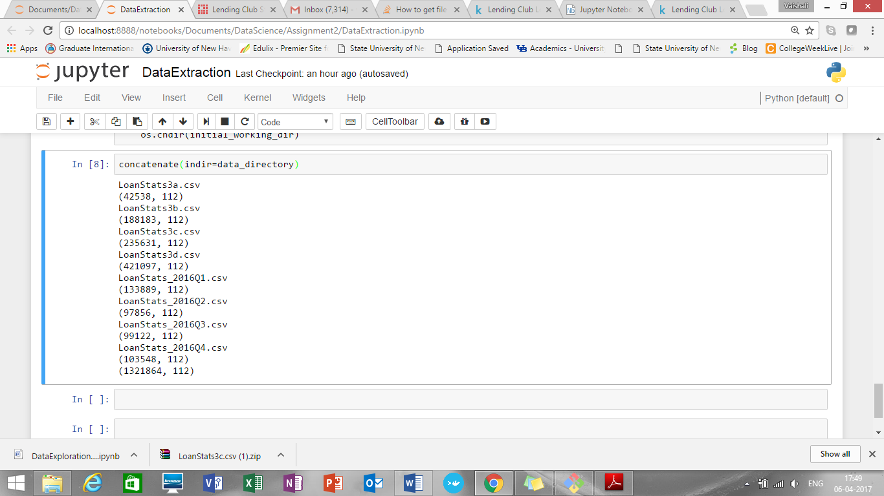

Added one more column timestamp to the data frame as below:

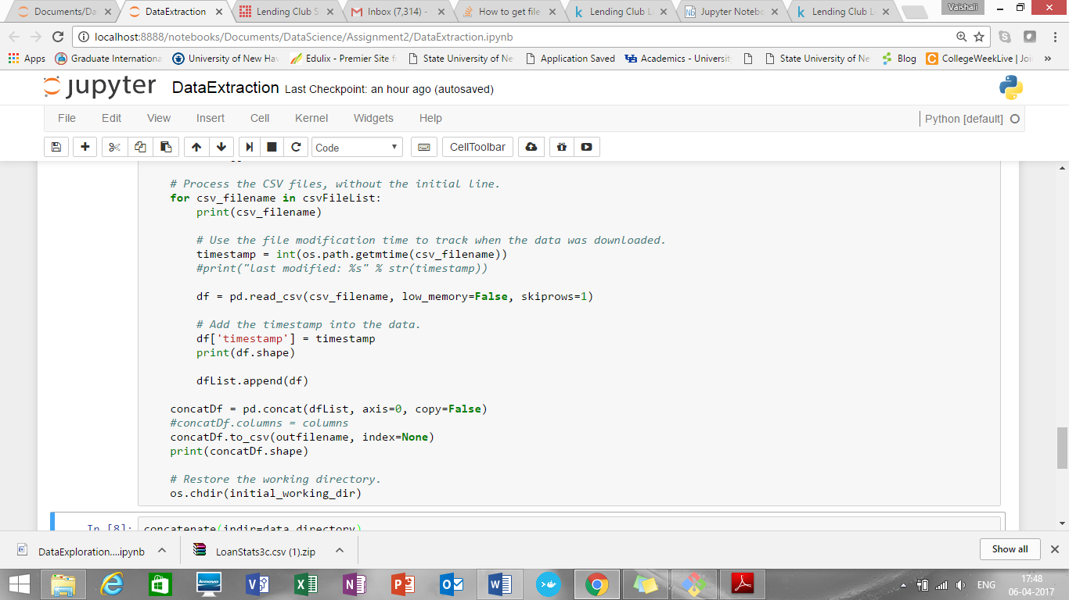

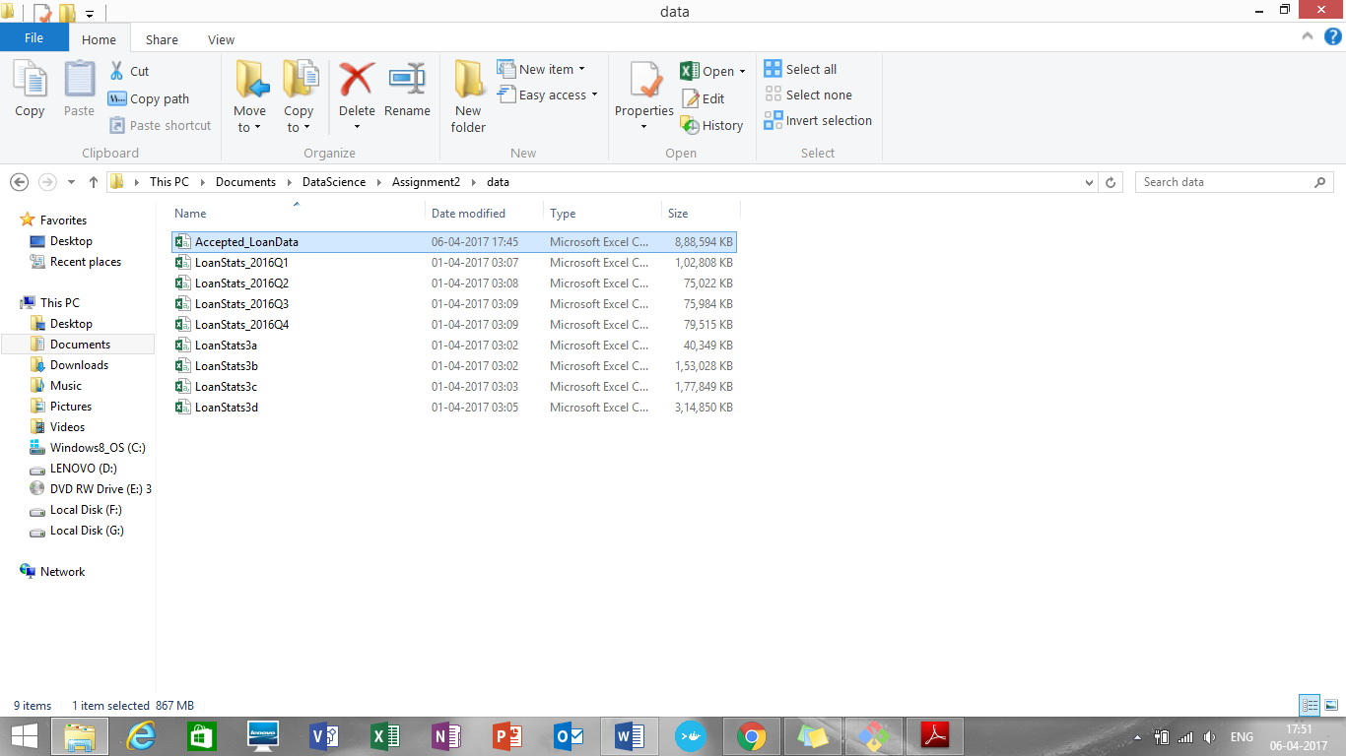

Also, we are providing check whether data files are already downloaded or not.

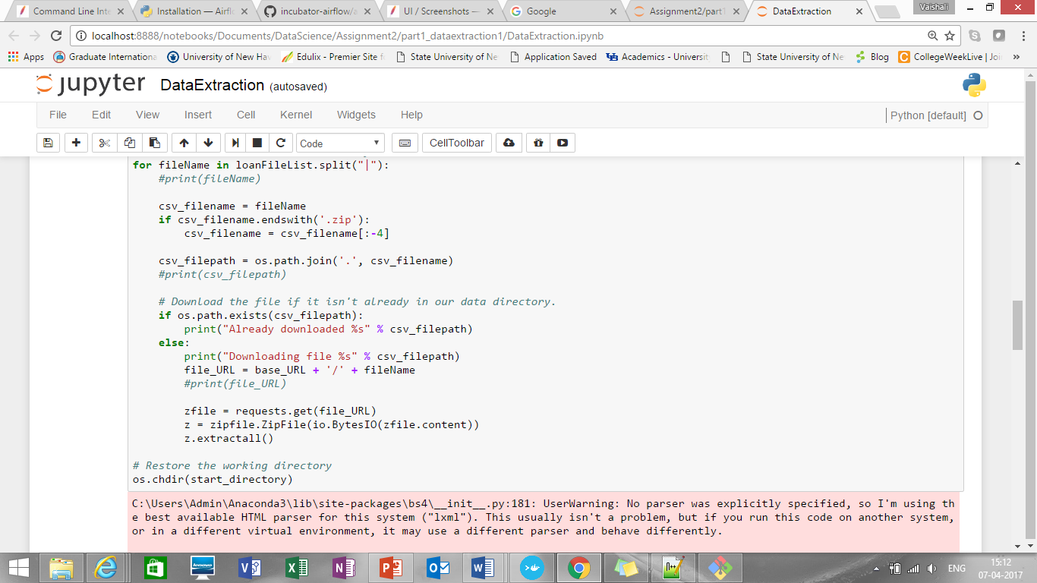

**Missing data handling:**

**Script Name: MissingDataHandling.ipynb/missingdatahandling1.py**

Checked data types of all column variables:

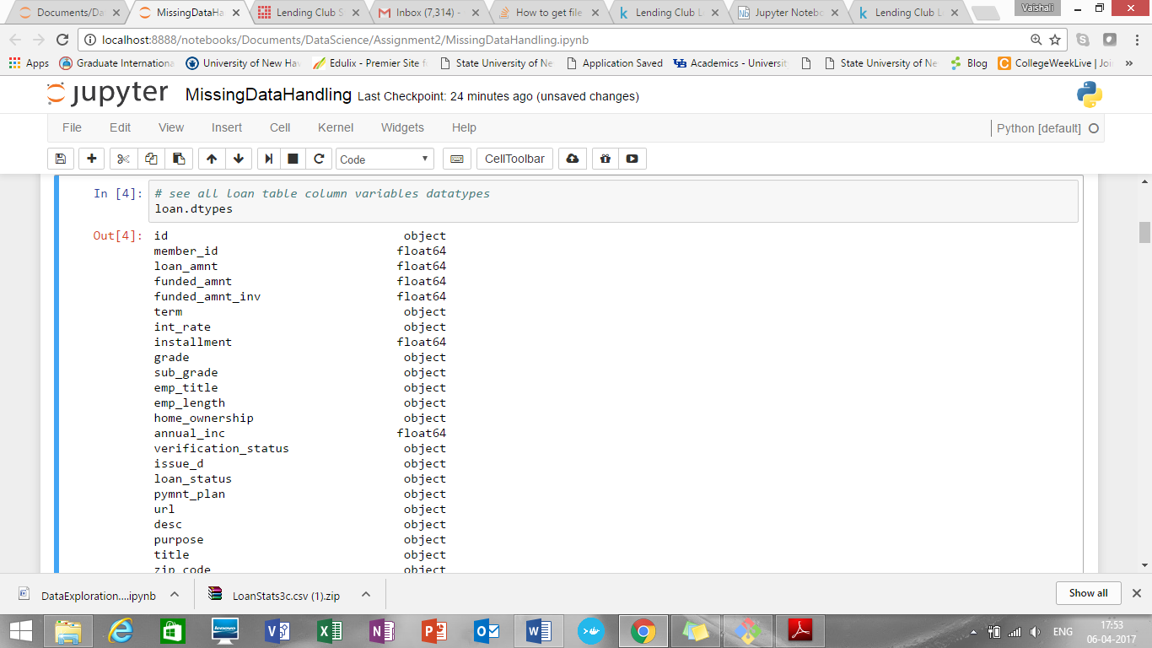

Find mean(), max(), min() of all column variables:

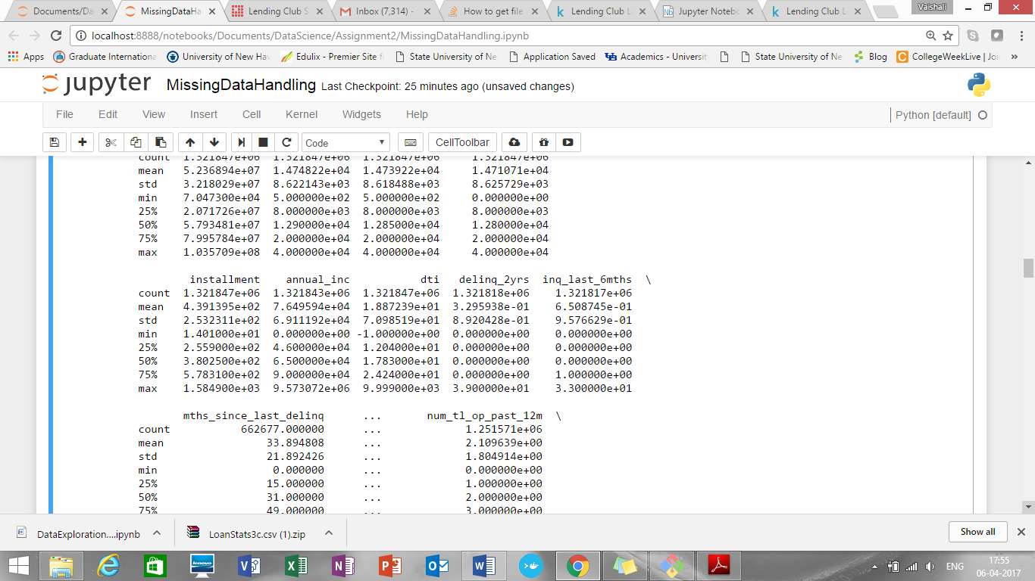

Handling categorical variables:

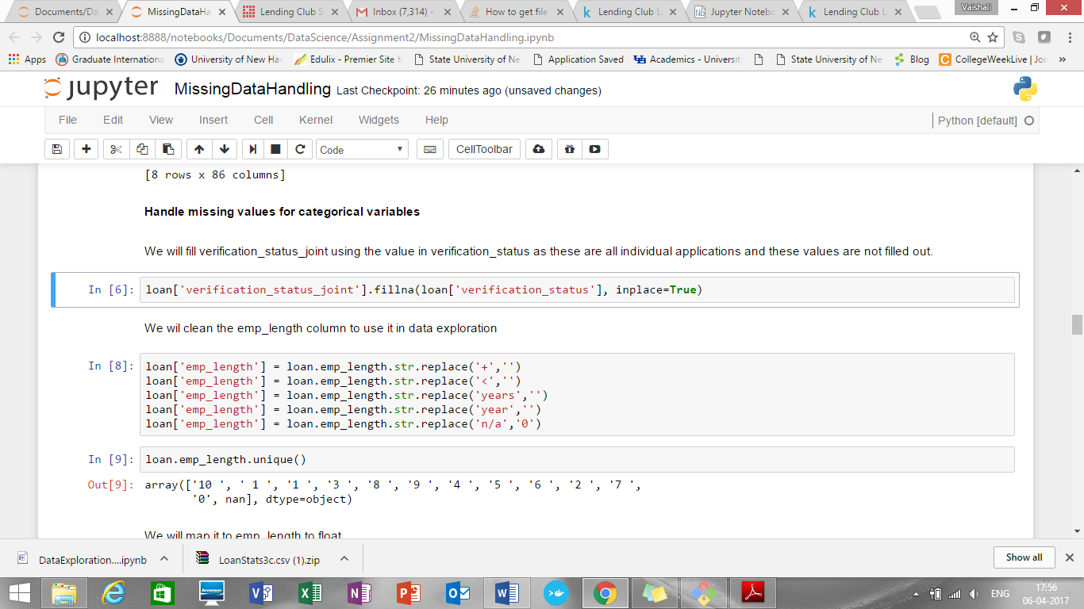  
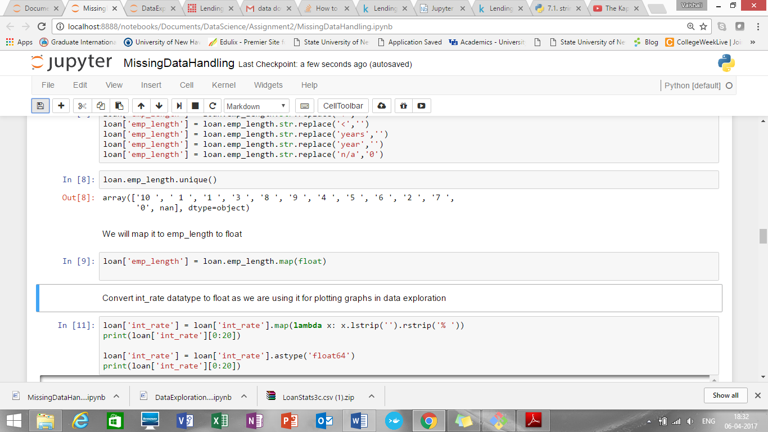To use int_rate to plot graphs need to convert datatype of it from object to float64

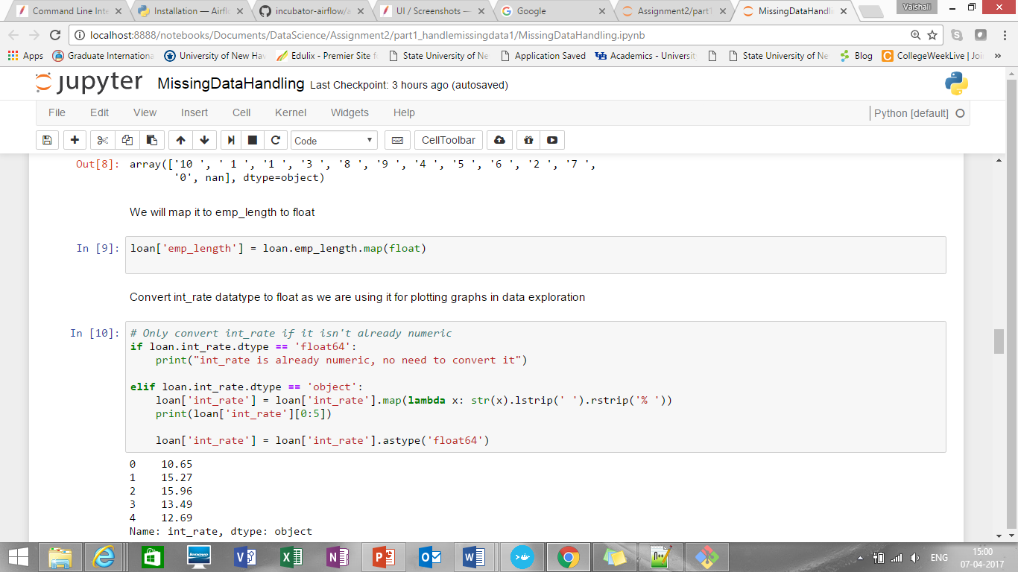

For the remaining categorical variables, we are just going to replace NaN with 'Unknown'.

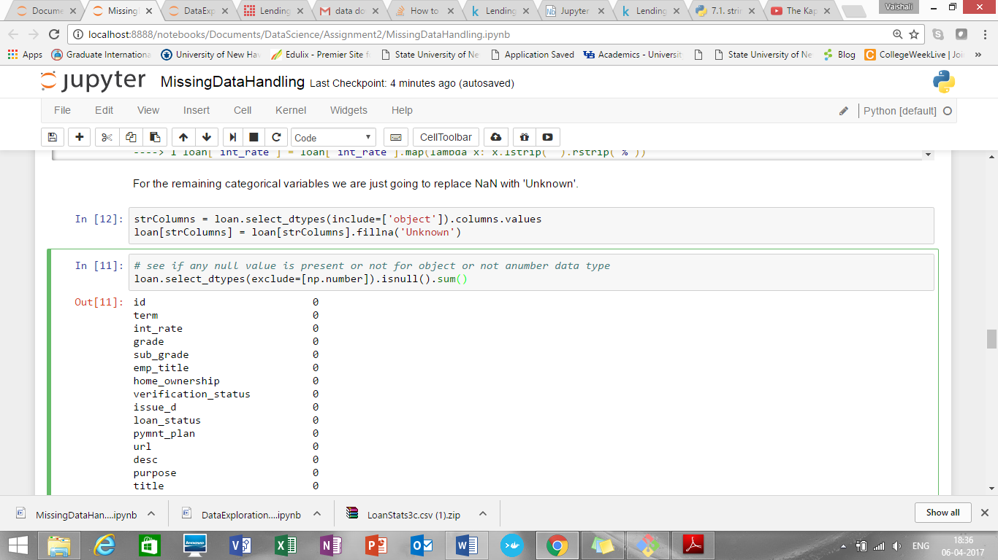

Checked all categorical variables again to find whether still there are any NaN values are present or not. Output shows that there is no NaN value left now.

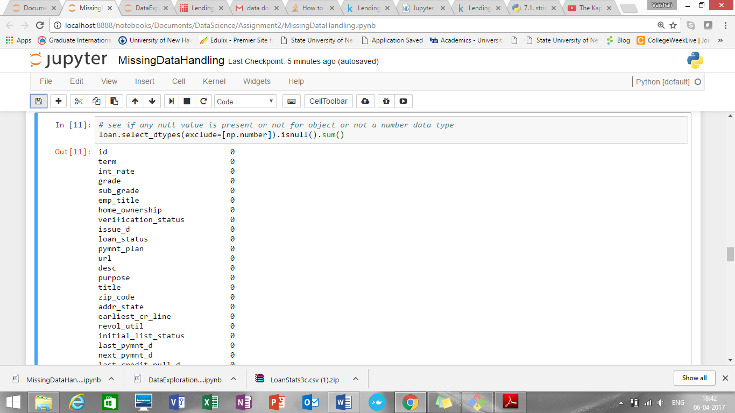

Check null values for numeric variable

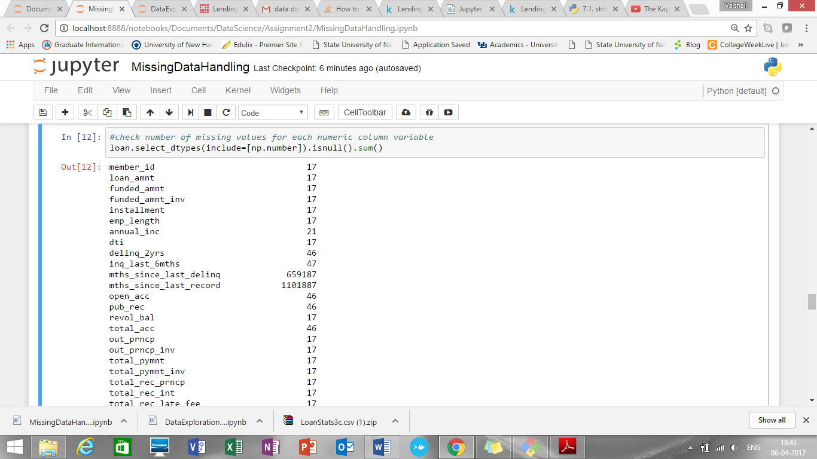

Handle missing values of numeric variables:

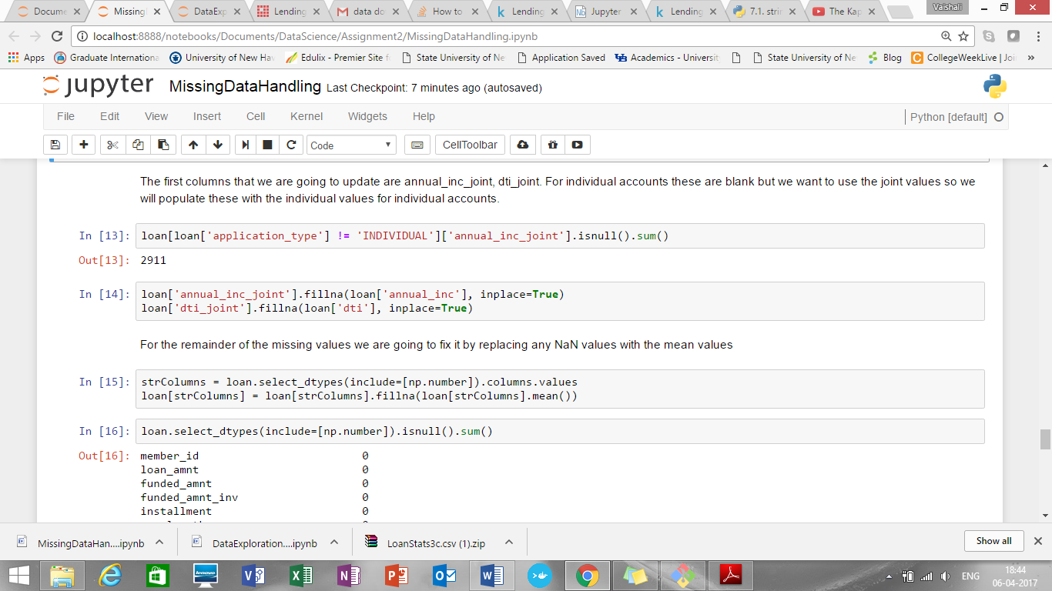

Column variables which has too many missing values (e.g. mths_since_last_record 1101887) we have dropped those columns:

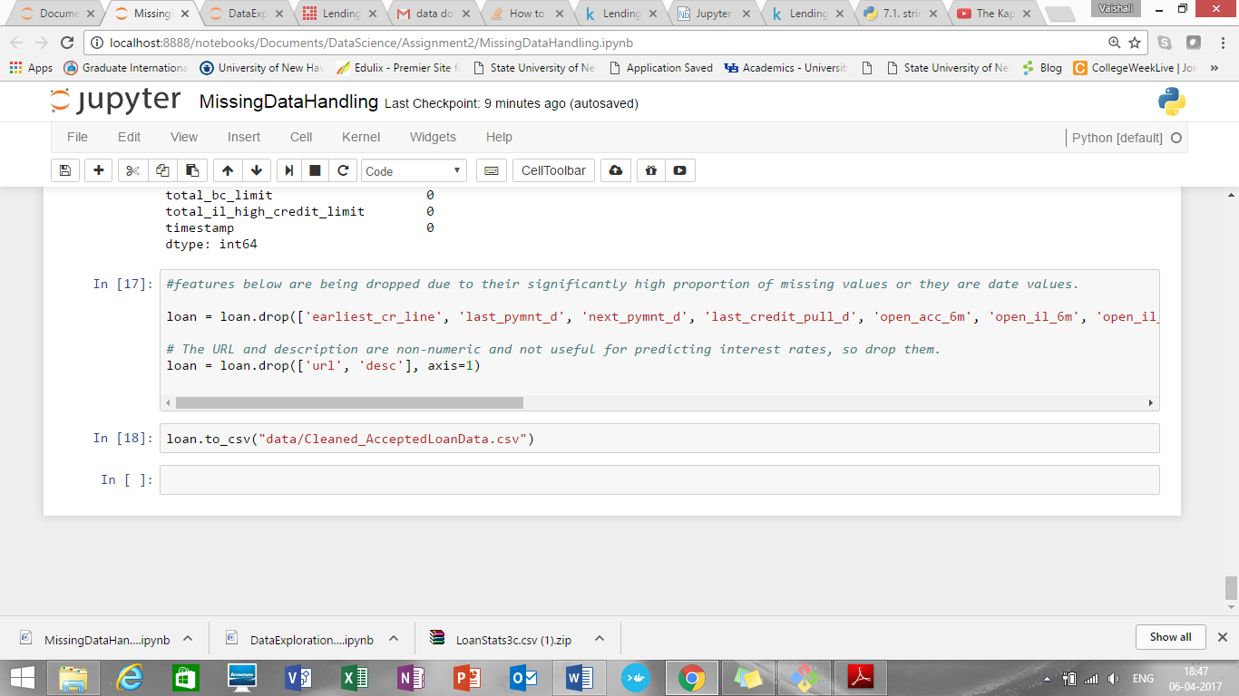

**Data Exploration using python:**

**Script Name: DataExploration.ipynb/dataexploartion1.py**

Annual_income and loan amount summary is:

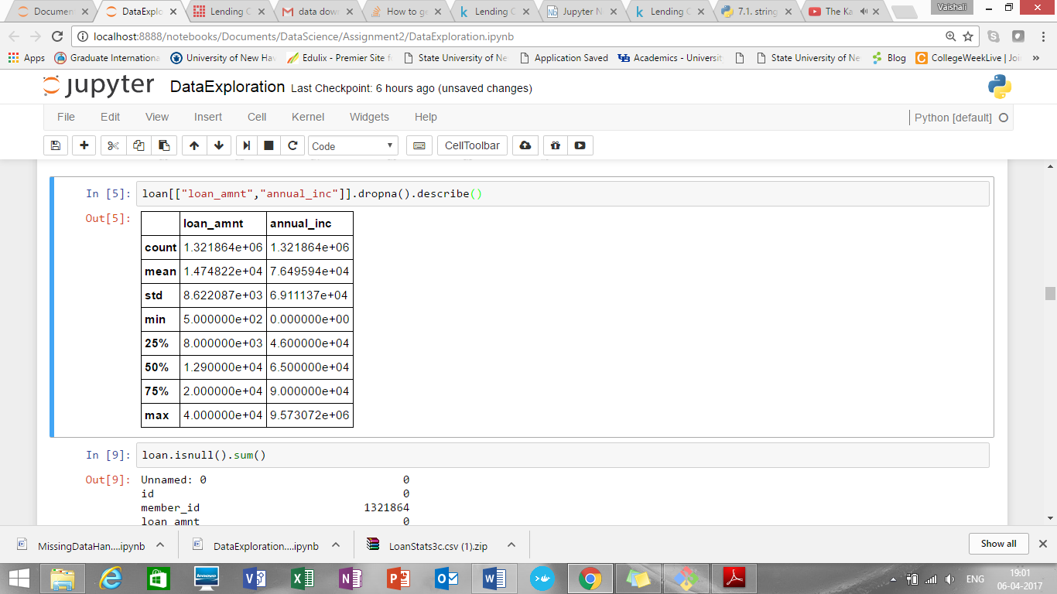

Distribution of int_rate:

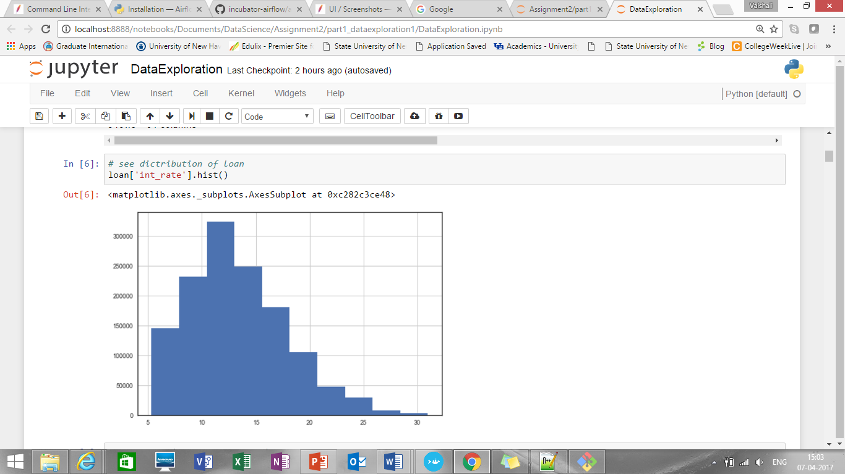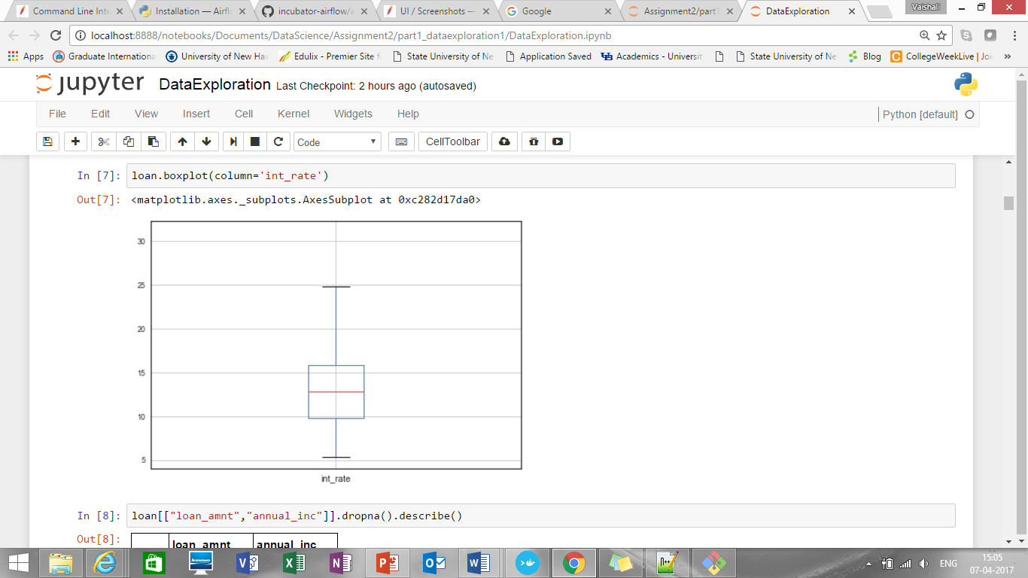

Median of interest rate is around 12 to 13%

1. Let’s see how loan amount affects interest rate:

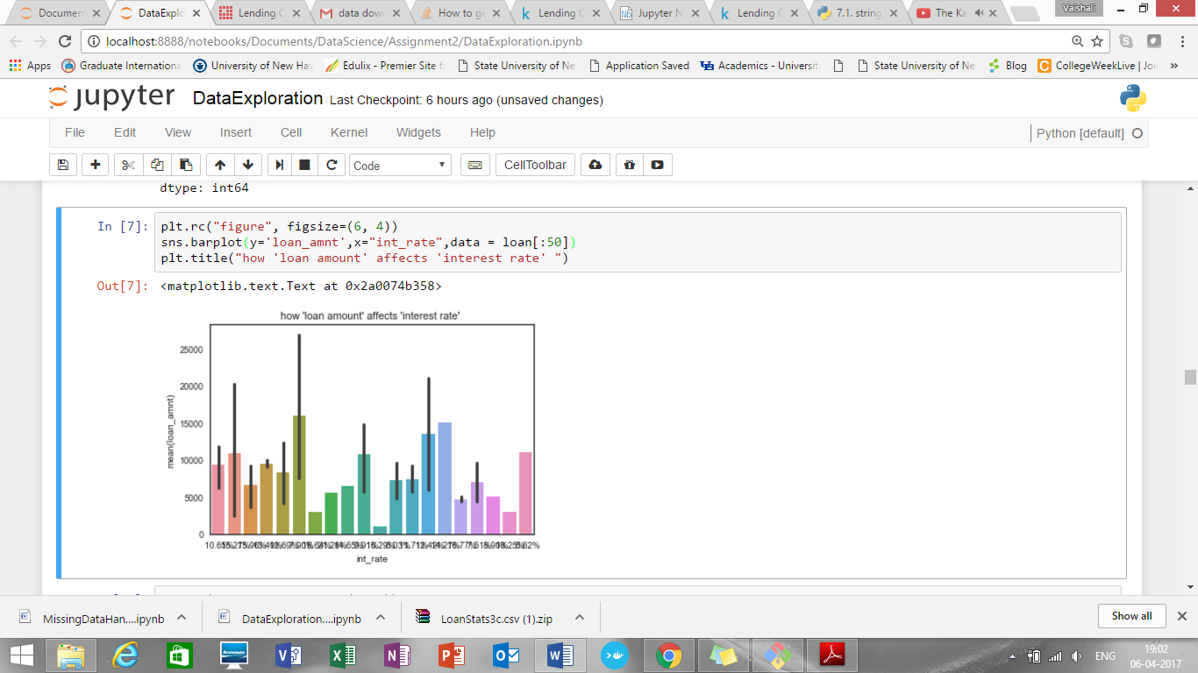

It shows that, lower the loan amount, higher the interest rate

1. Let’s see how annual income affects interest rate:

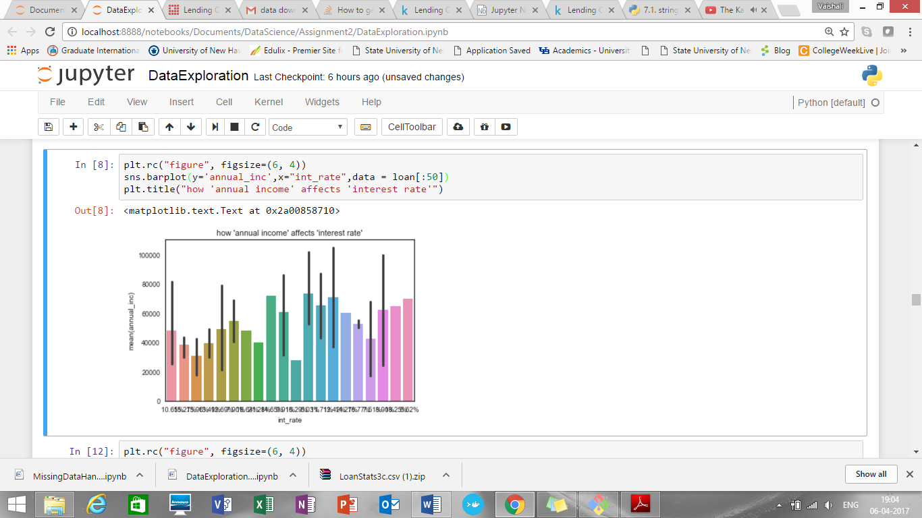

1. How term and interest rate are related

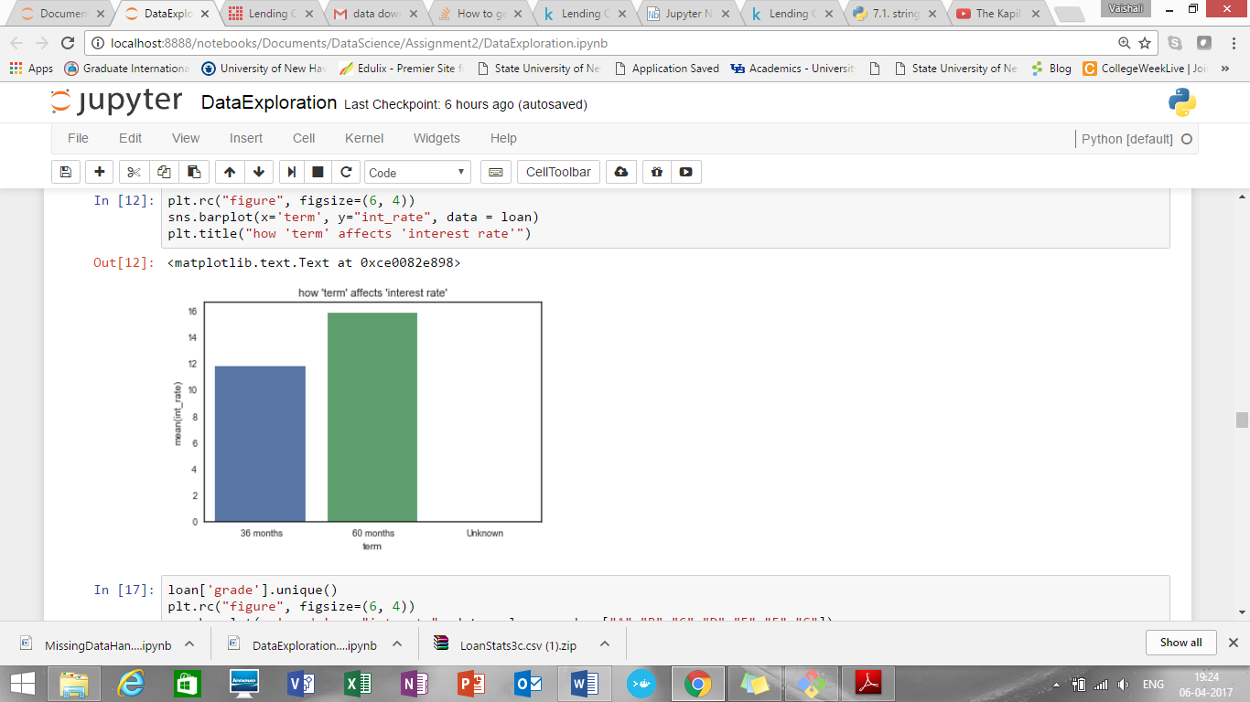

So, for higher term i.e. 60 months, interest rate is higher

1. How interest rate and grade are connected

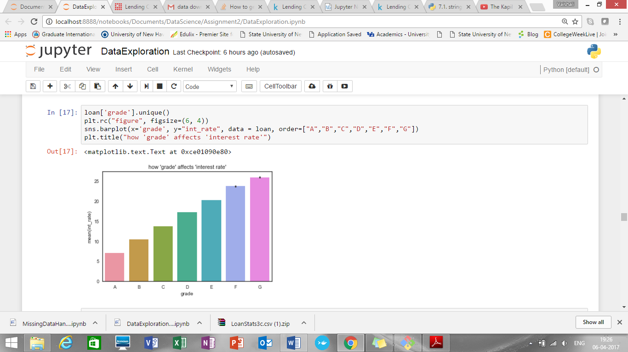

1. Let’s see how issue month or issue year affect the interest rate

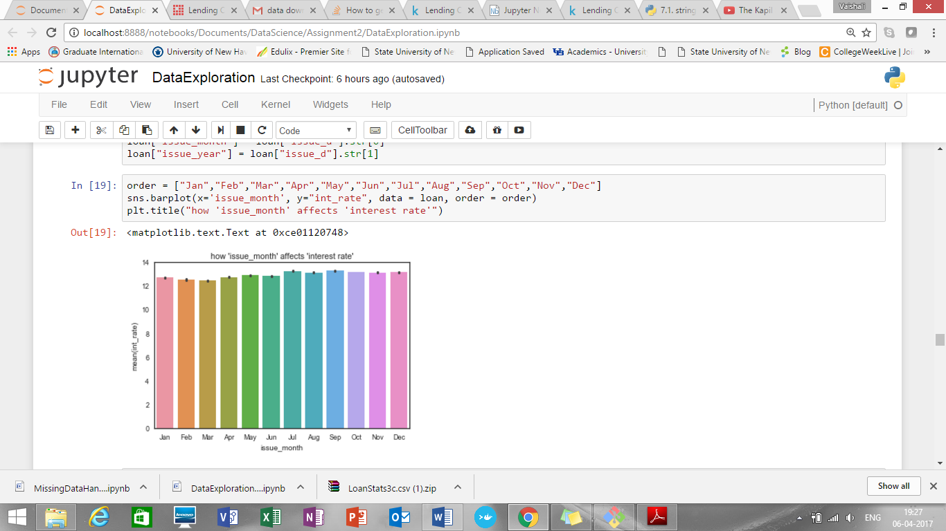

It shows that issue month has no such big impact on interest rate

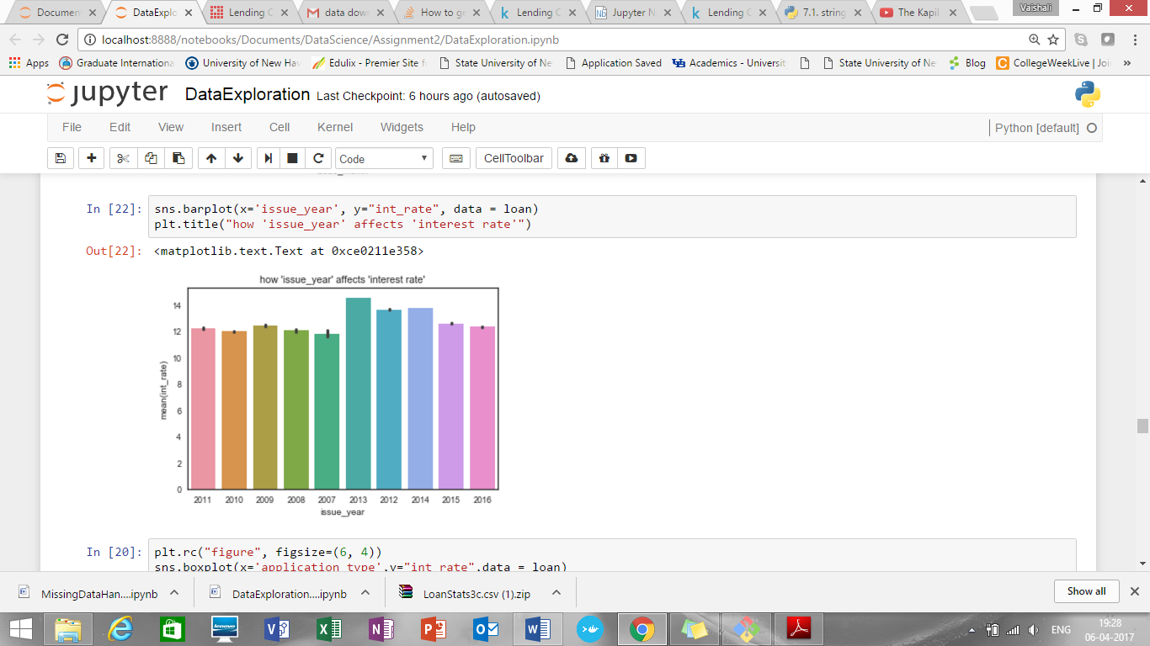

Also, issue year shows that, maximum interest was in 2013. Afterwards it again falls and in 2015 and 2016 there is little drop in interest rate

1. Application type Vs interest rate

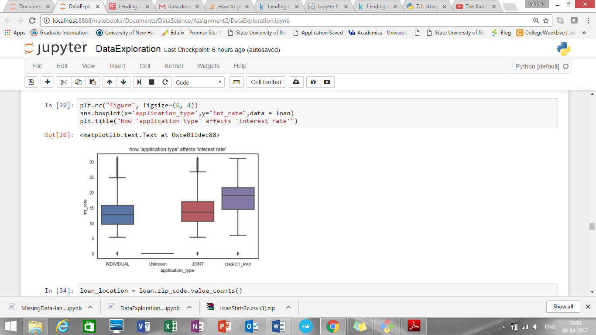

It shows that for “INDIVIDUAL” application type there is lowest interest rate compare to Joint and direct pay applications

1. Maximum borrowers are in CA
2. Loan status count for Current is maximum

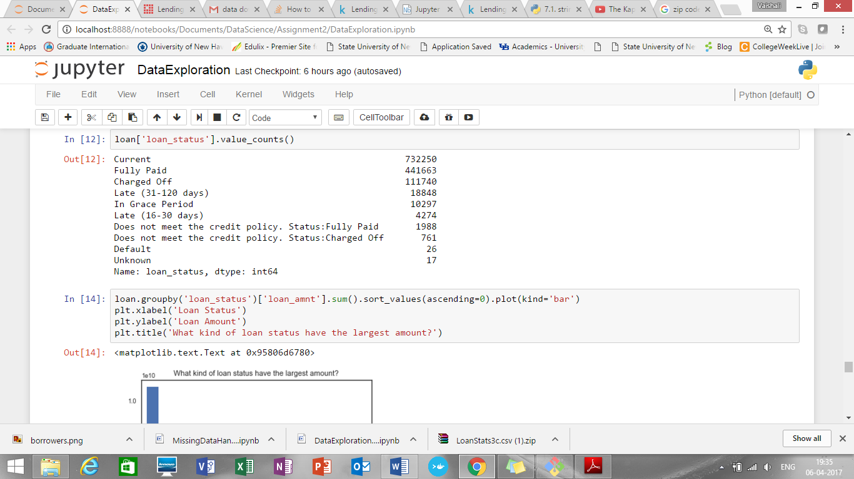

1. So, maximum loan amount is in Current loan status

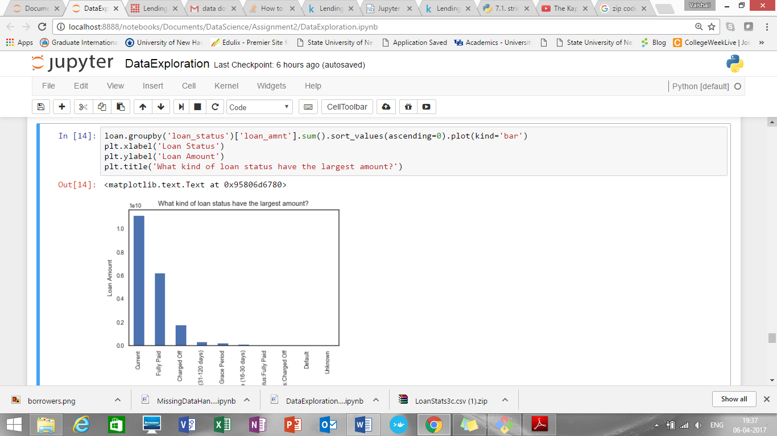

1. Maximum borrowers are found for loan for purpose “Debt consolidation”

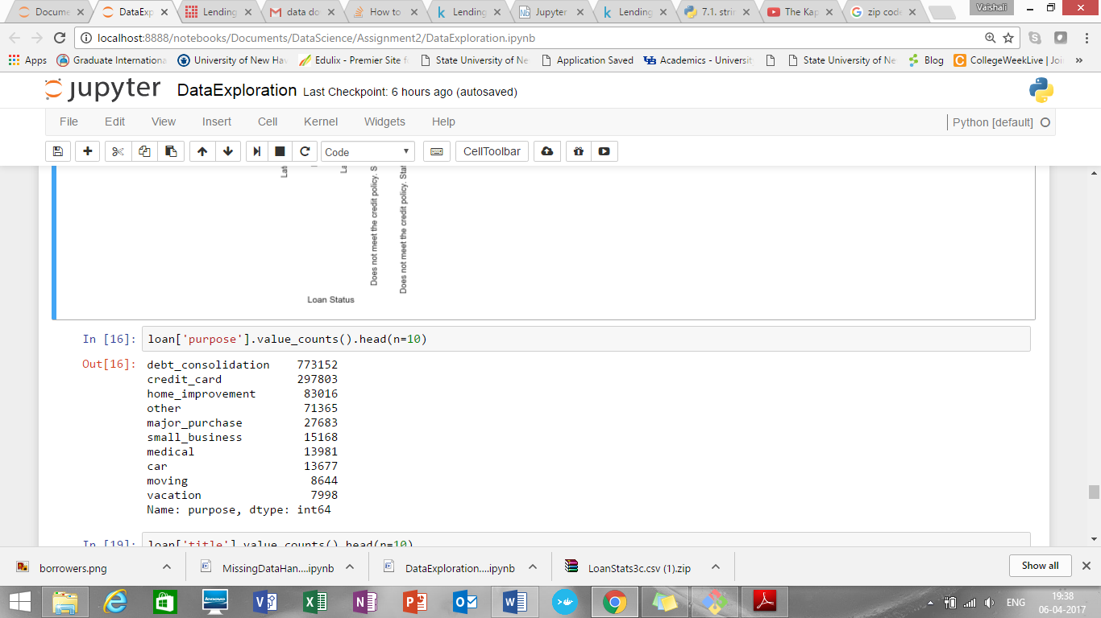

1. Volume of loan is maximum for Grade “B”

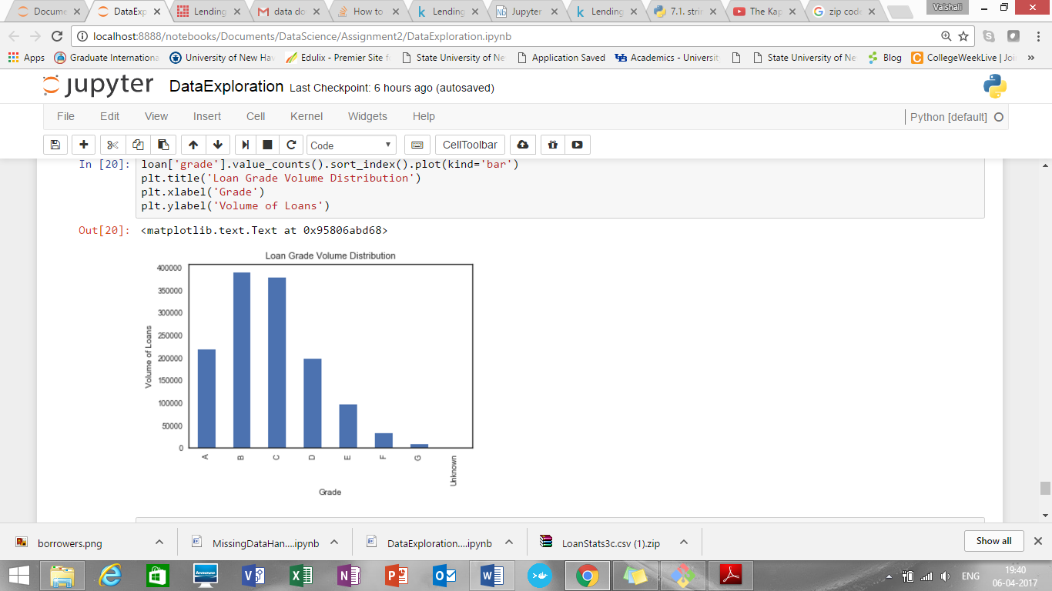

1. Amount of loan is maximum for grade” C”

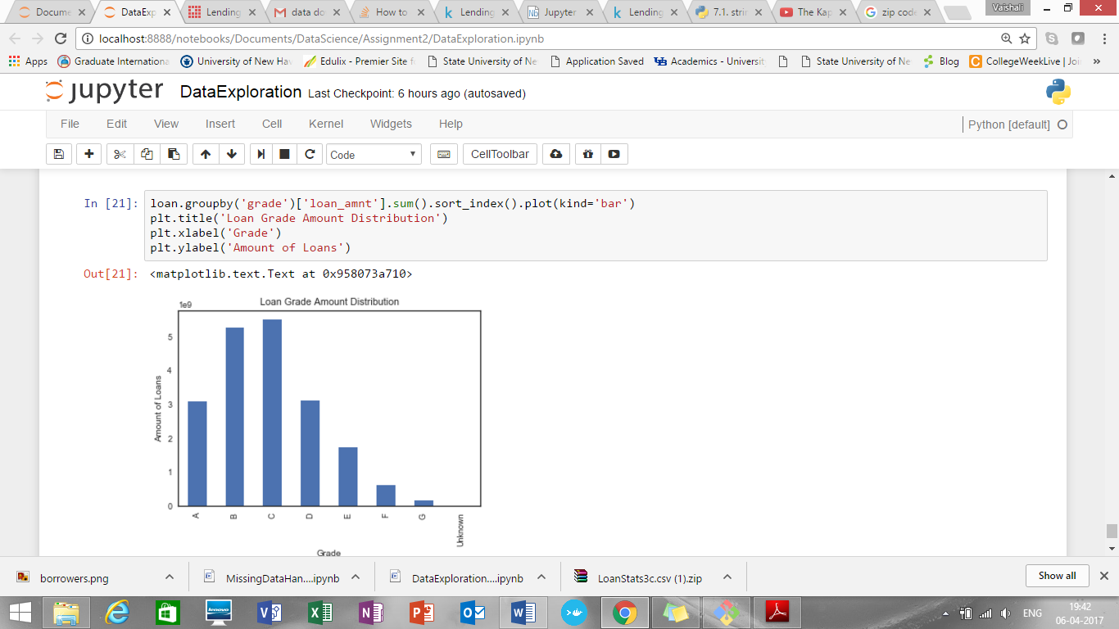

1. Number of loans Vs annual income

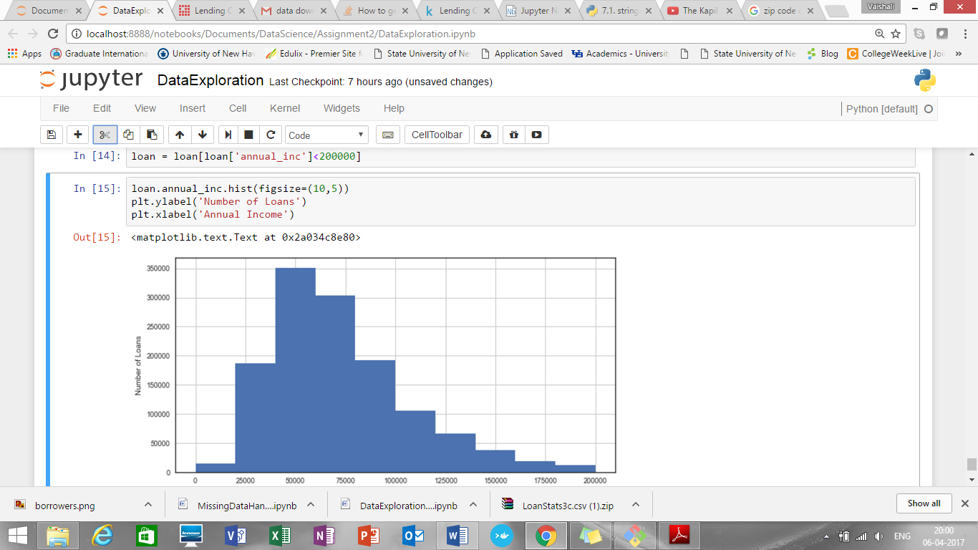

From above exploration, we can see that loan amount, annual income, term, state, purpose, loan status, grade has impact on interest rate. SO these variables will be helpful to predict the interest rate .

Number of loans are maximum for annual income in range 4000-6000 approximately

1. Create “default” for loan status

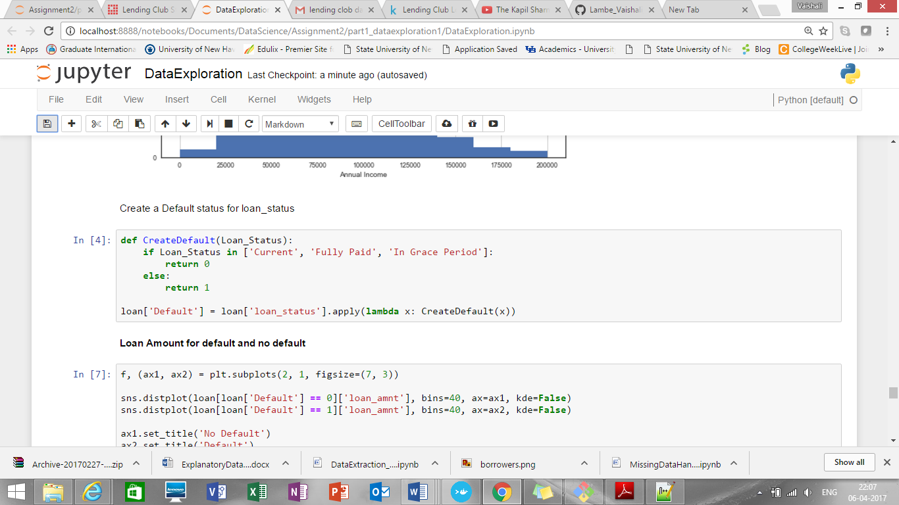

1. **Loan Amount for default and no default**

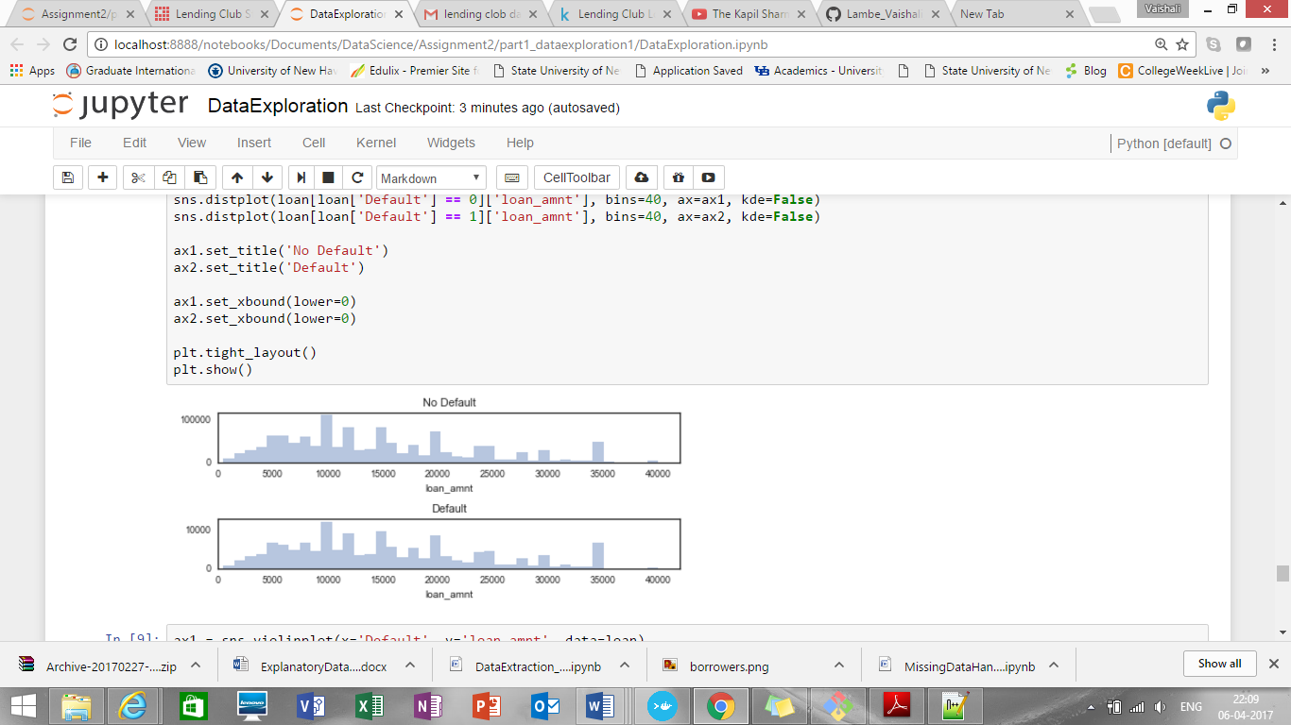

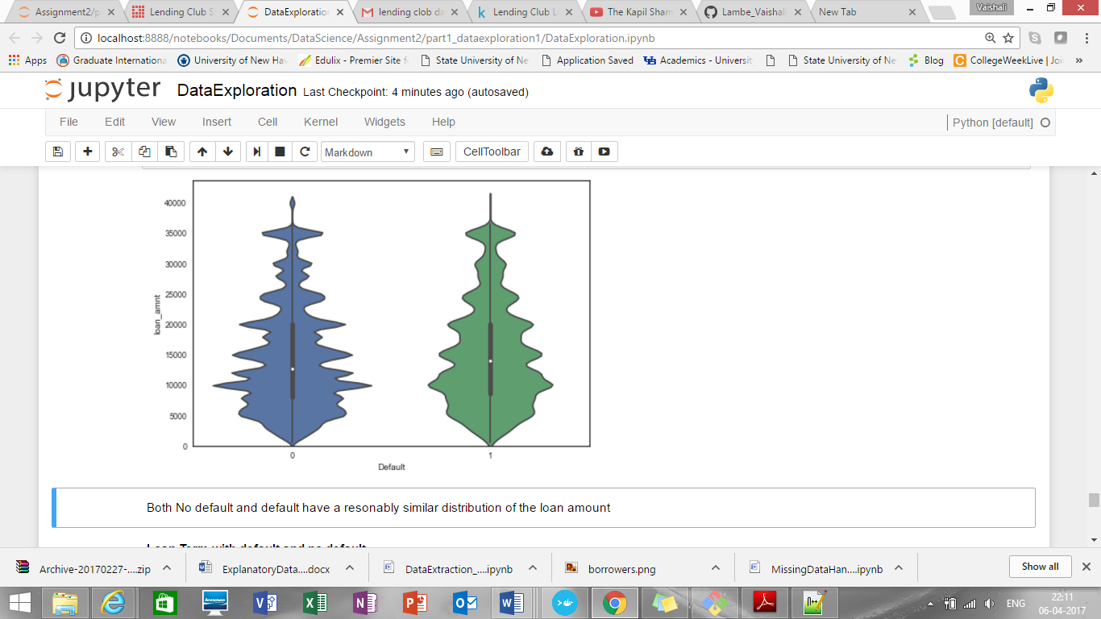

Both No default and default have a reasonably same distribution of the loan amount

1. **Loan Term with default and no default**

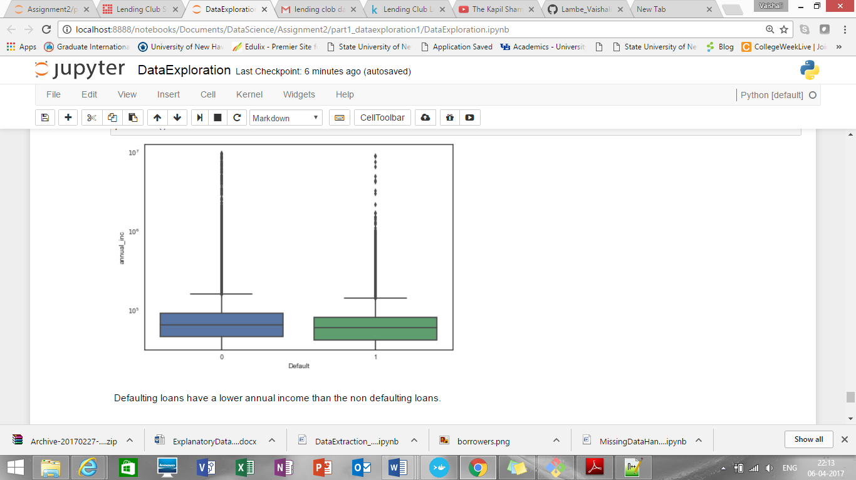

1. **Debt to income ratio for default and no default**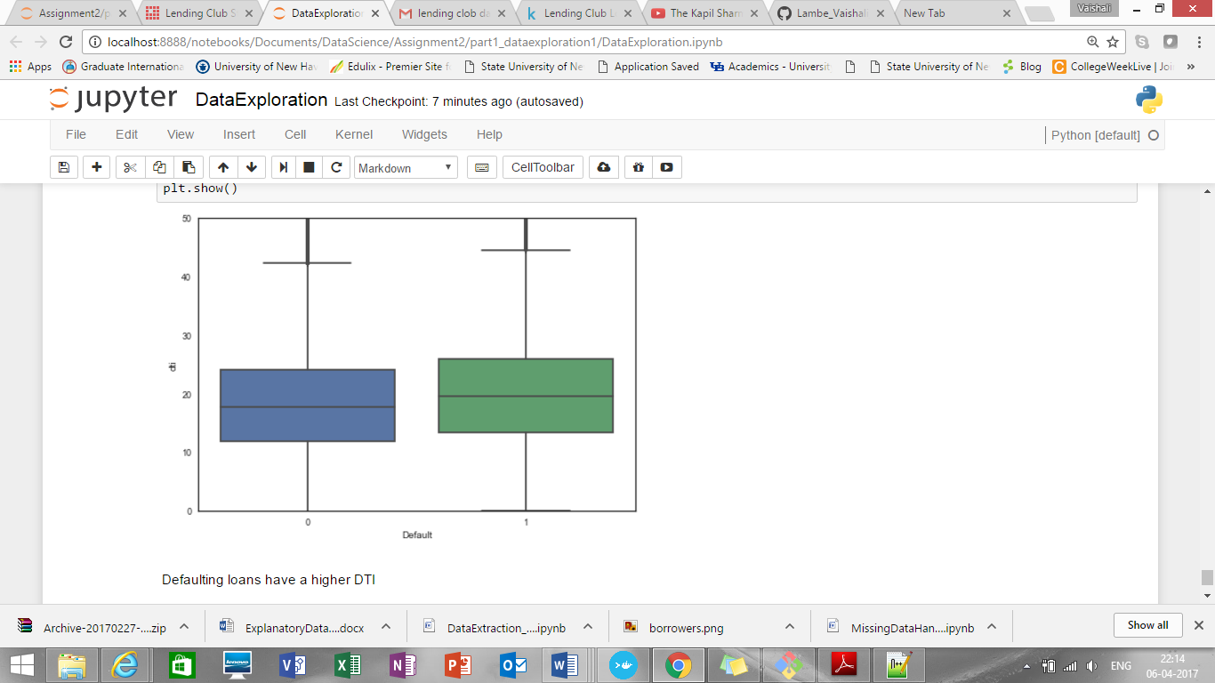

**Data Download and pre-processing (Declined Loan Data):**

**Script Name: DataExtraction.ipynb/DataExtraction_DeclinedLoanData.py**

**Downloads data from**

<https://www.lendingclub.com/info/download-data.action>

As sign in require lot of inputs to provide, didn’t create the login. Directly downloading data from the url. Created one data set from multiple .csv files as Rejected_LoanData.csv

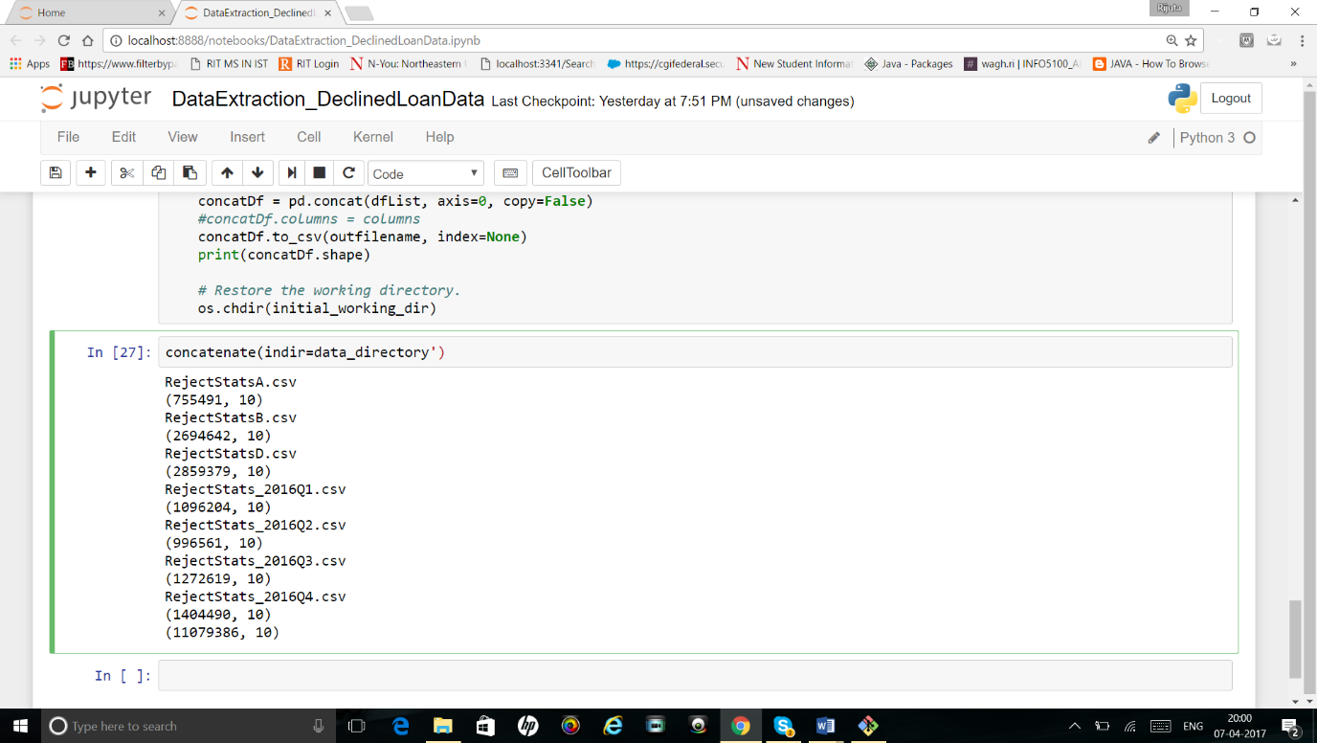

Added one more column timestamp as below:

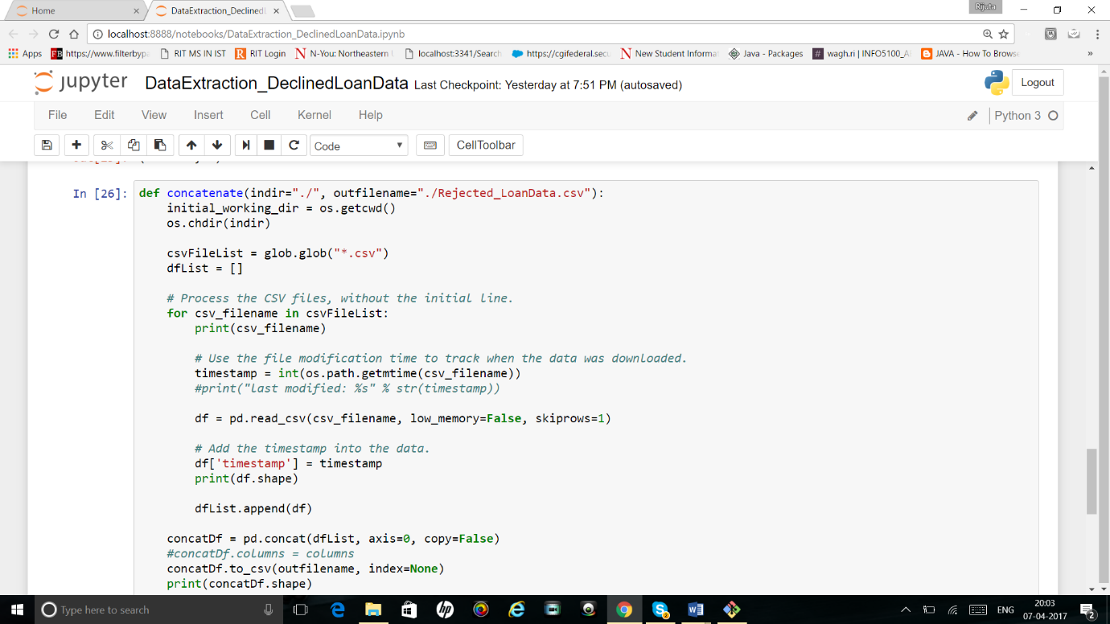

1. Also, we are providing check whether data files are already downloaded or not.

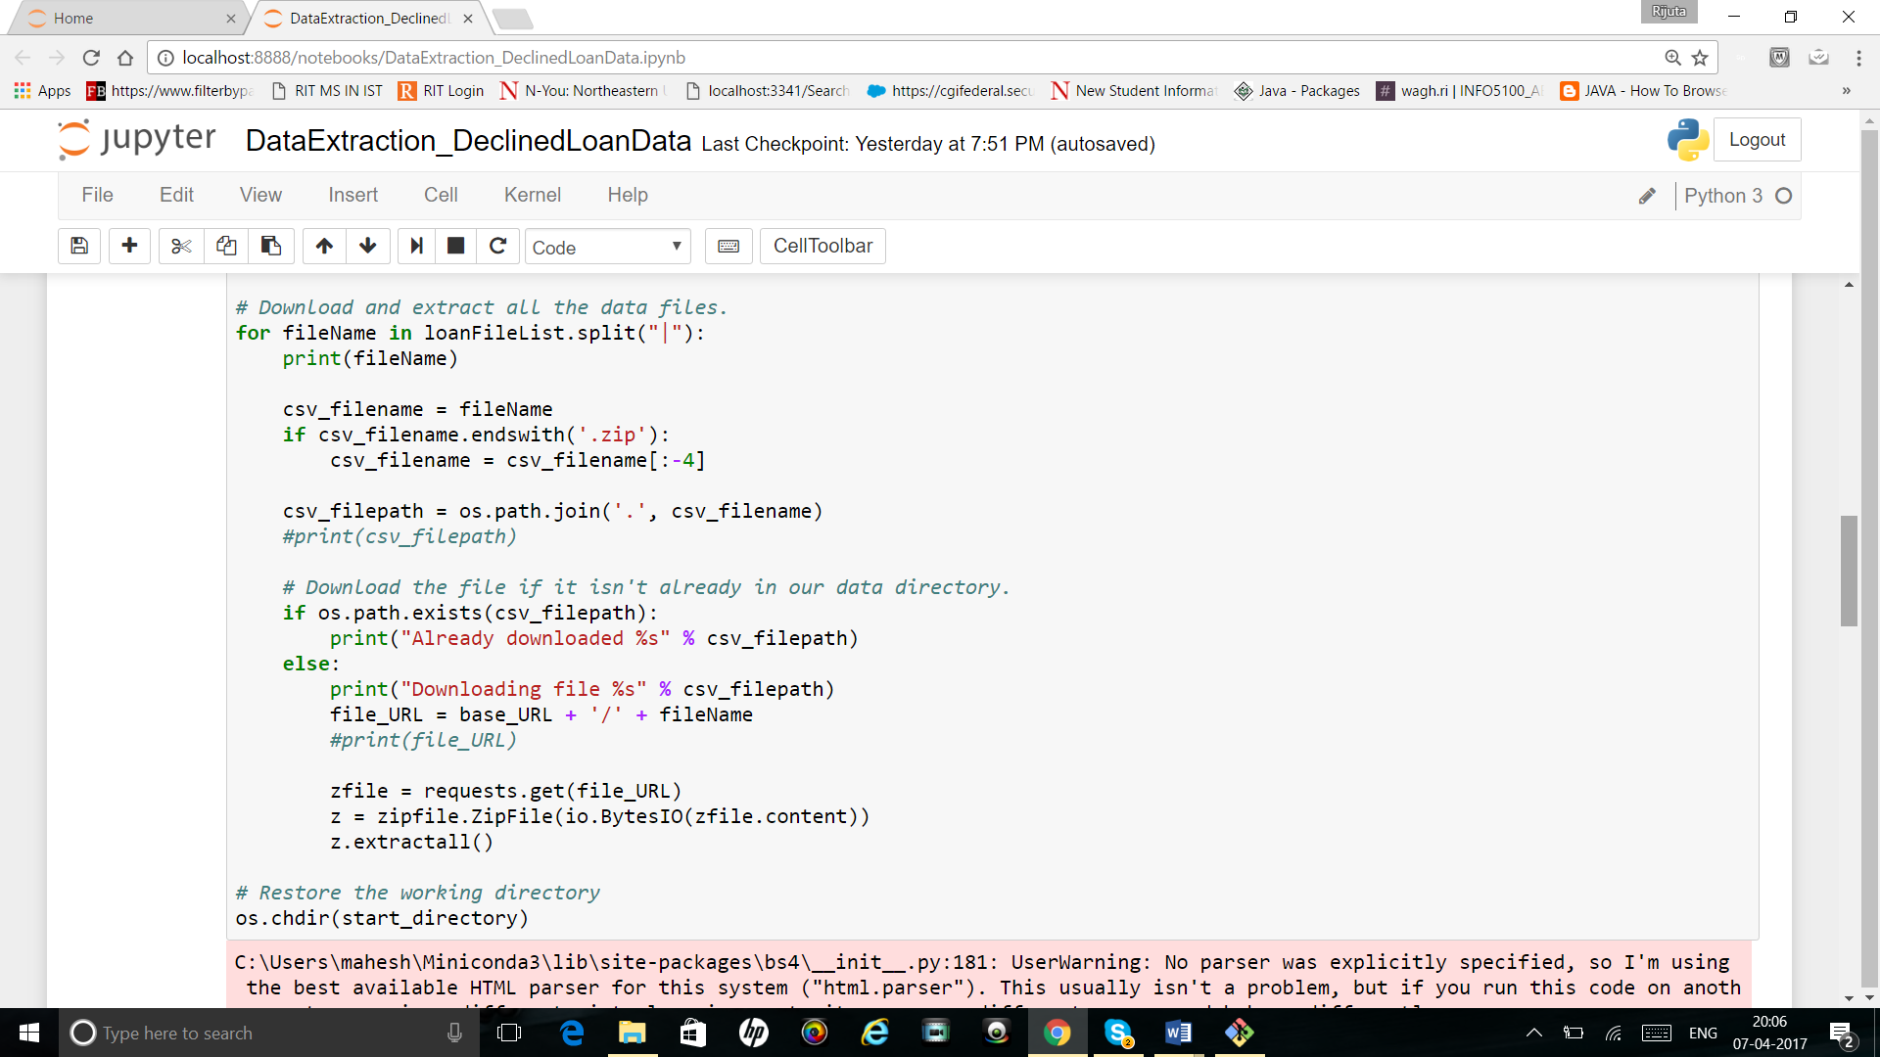

**Missing data handling:**

**Script Name for both Missing Data Handling and Exploratory Data Analysis: MissingDataHandling.ipynb/MissingDataHandling_DataExploration_DeclinedLoans.py**

Checked data types of all column variables:

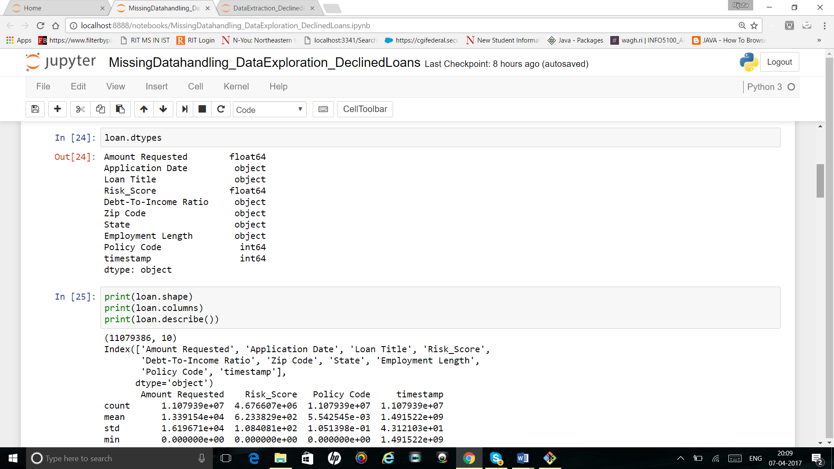

Find mean(), max(), min() of all column variables:

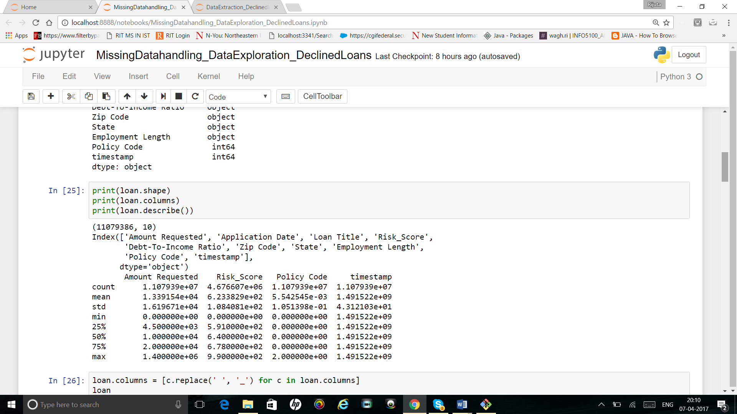

**Handling categorical variables:**

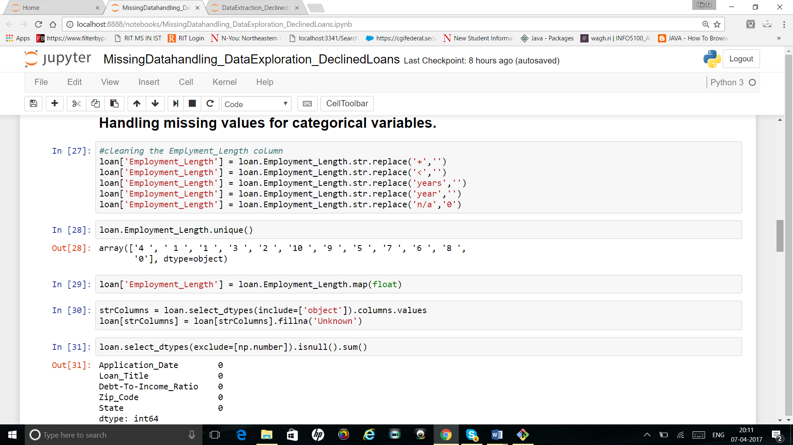

For the remaining categorical variables, we are just going to replace NaN with 'Unknown'.

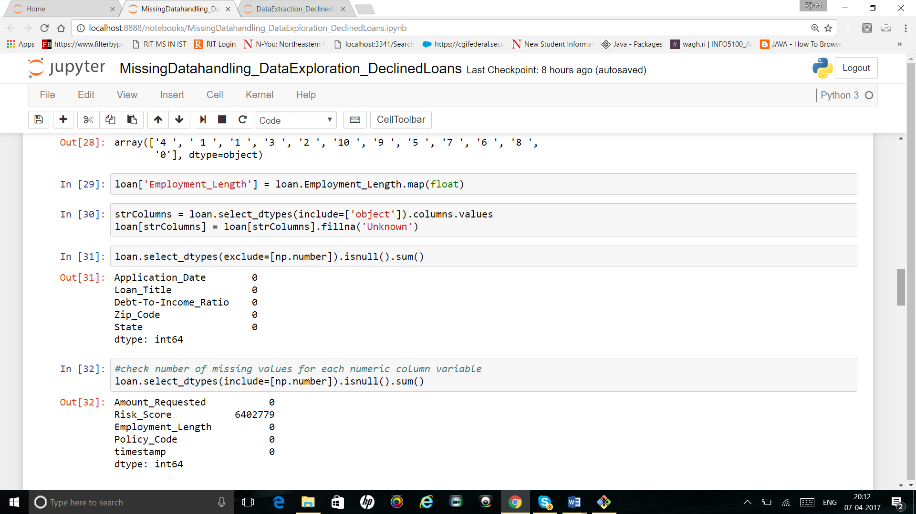

Checked all categorical variables again to find whether still there are any NaN values are present or not. Output shows that there is no NaN value left now.

Handling missing values of numeric variables:

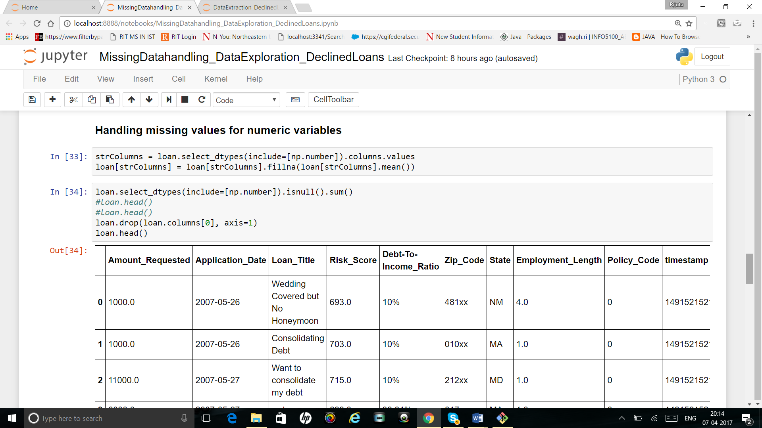

**Data Exploration using python:**

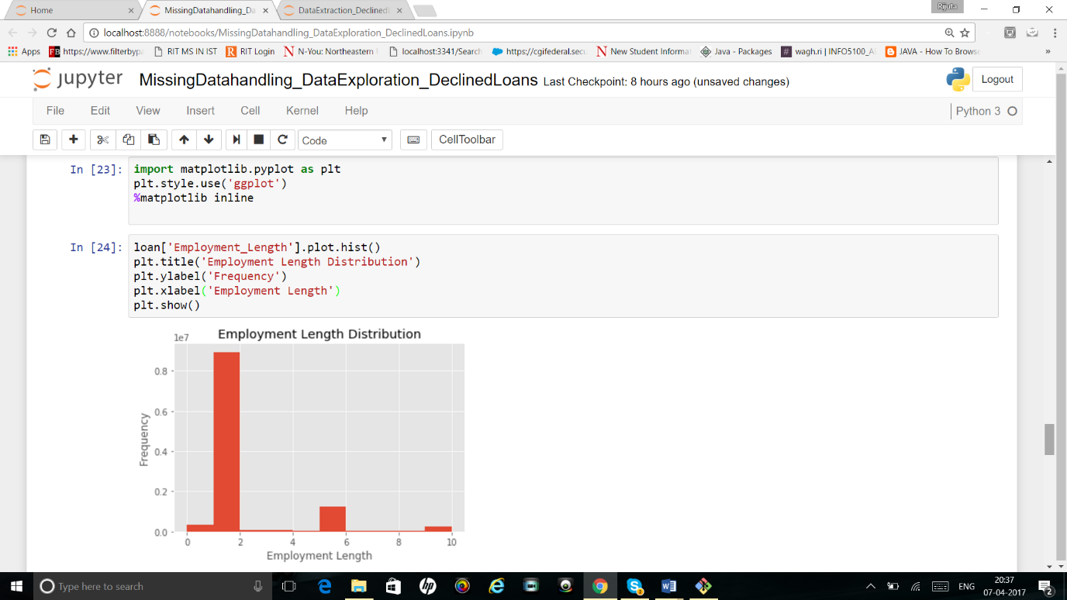

1. 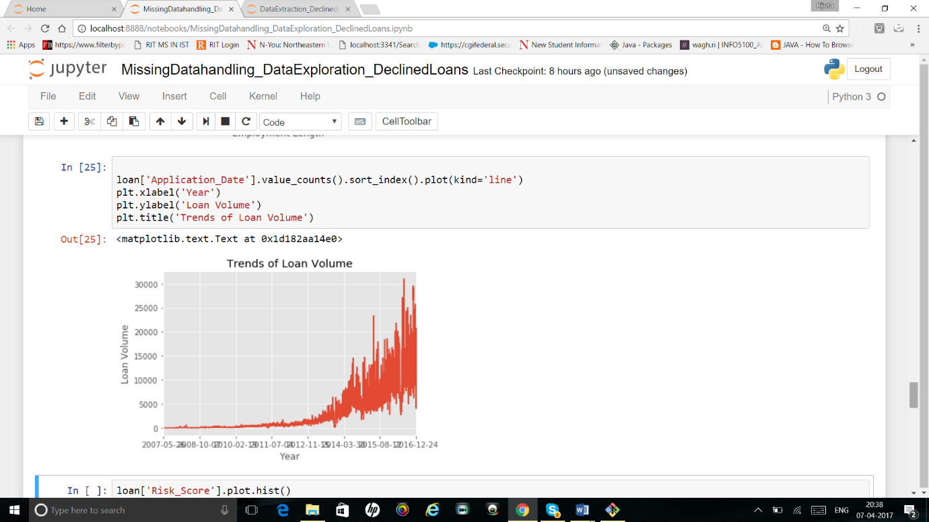

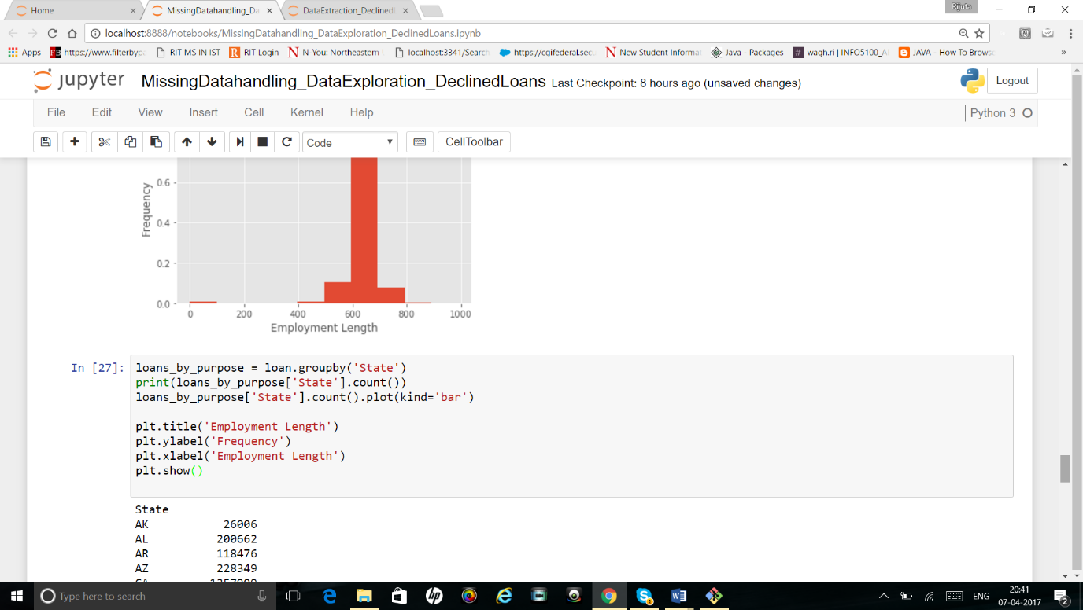

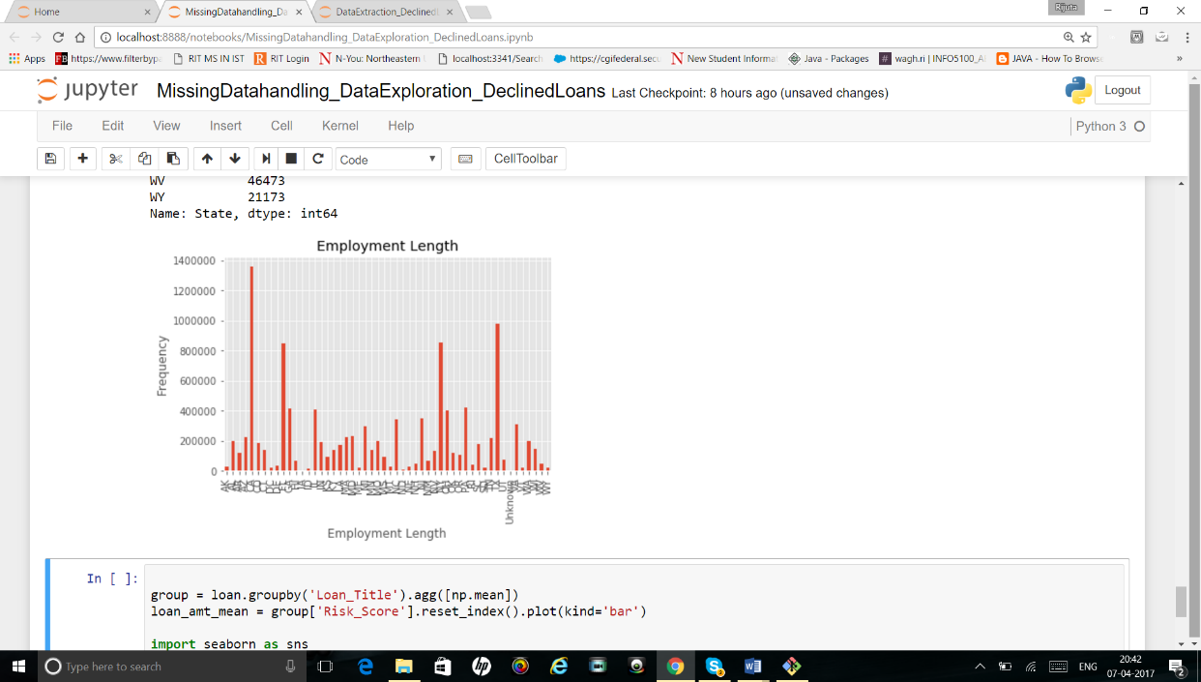

**PowerBI Analysis:**

Accepted Data Dashboard 1

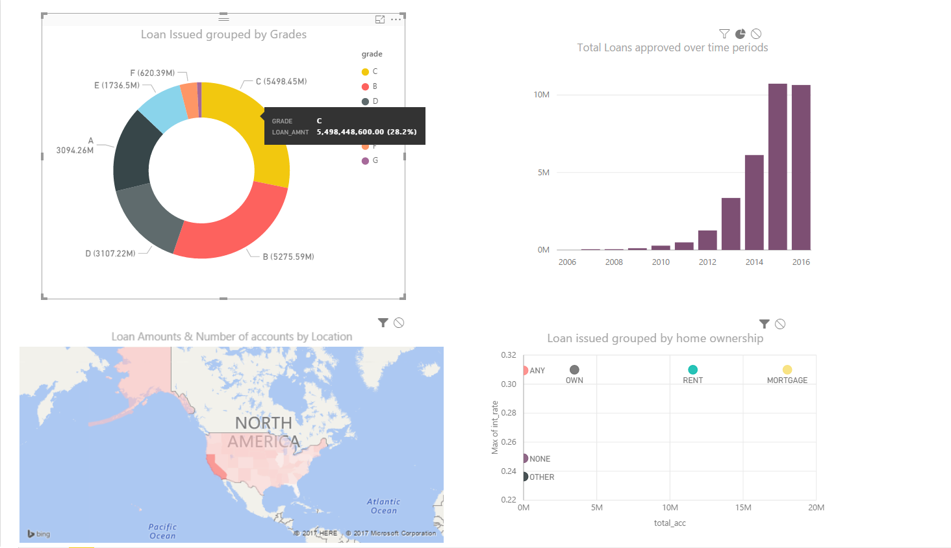

Accepted Data Dashboard 2

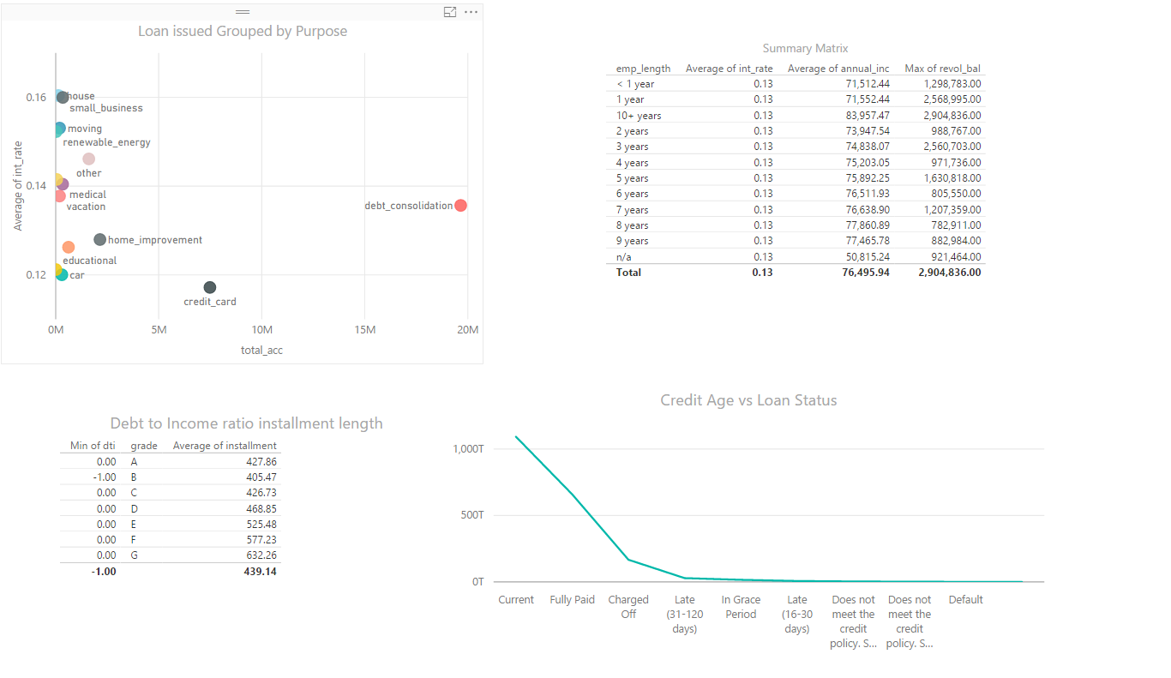

Time Hierarchy : over the years Loan approved

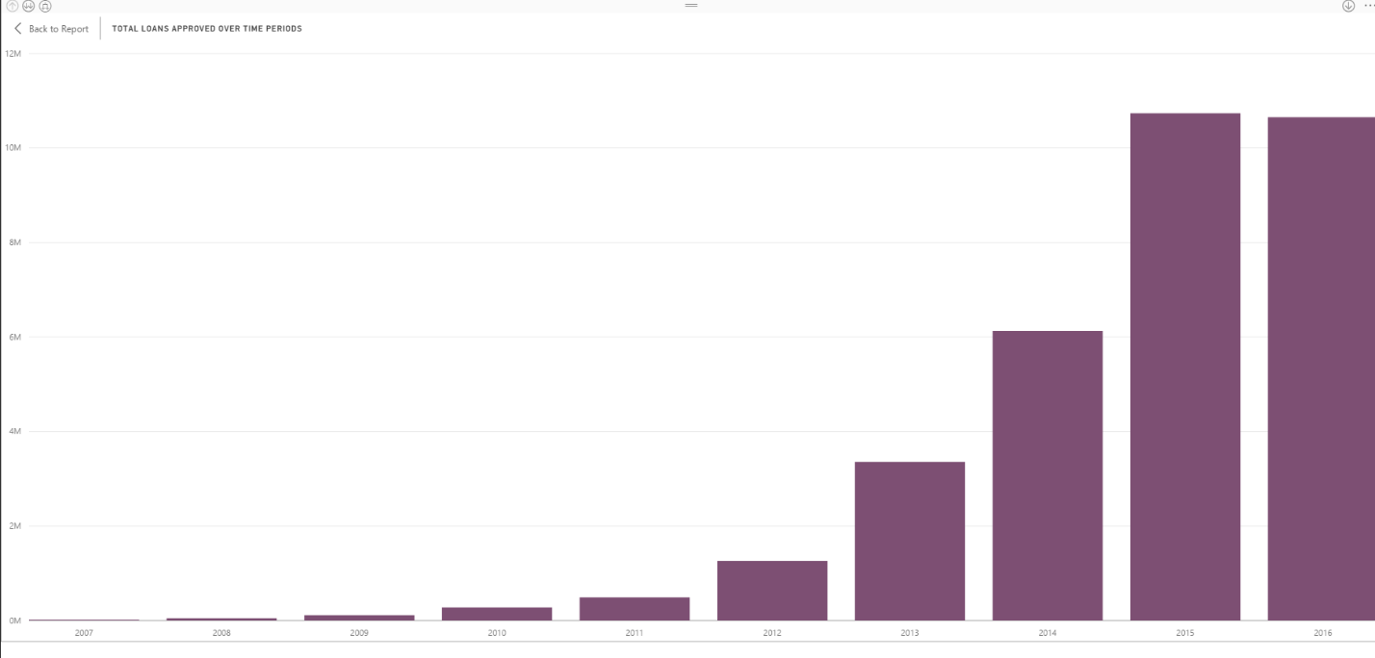

Time Hierarchy : Quarterly Loan approved

So it seems that the most loans are approved in quarter 4 then followed by quarter 3 then in 1st quarter

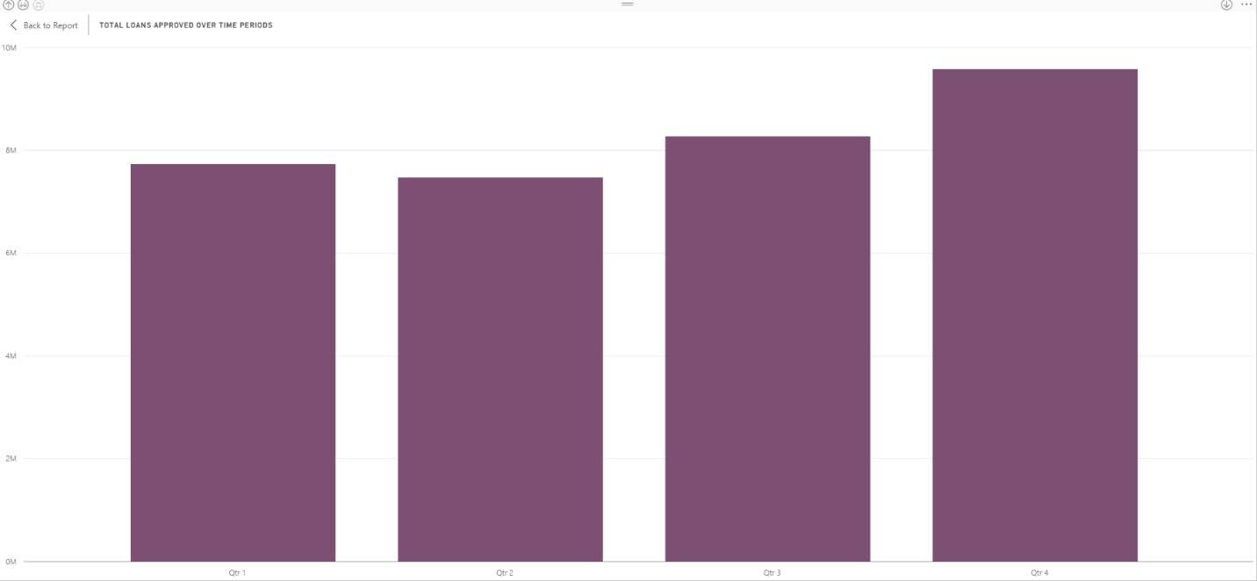

Time Hierarchy : monthwise Loan approved

Monthly loan approved which says October is the month with most approvals

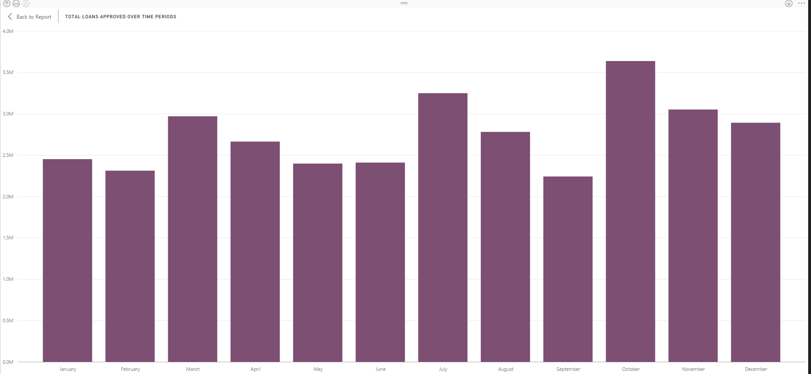

Donut -Loan Issued grouped by Grades

Show how loan varies with percentage. Those who are graded under C grade have been issued maximum loans followed by B grade then A

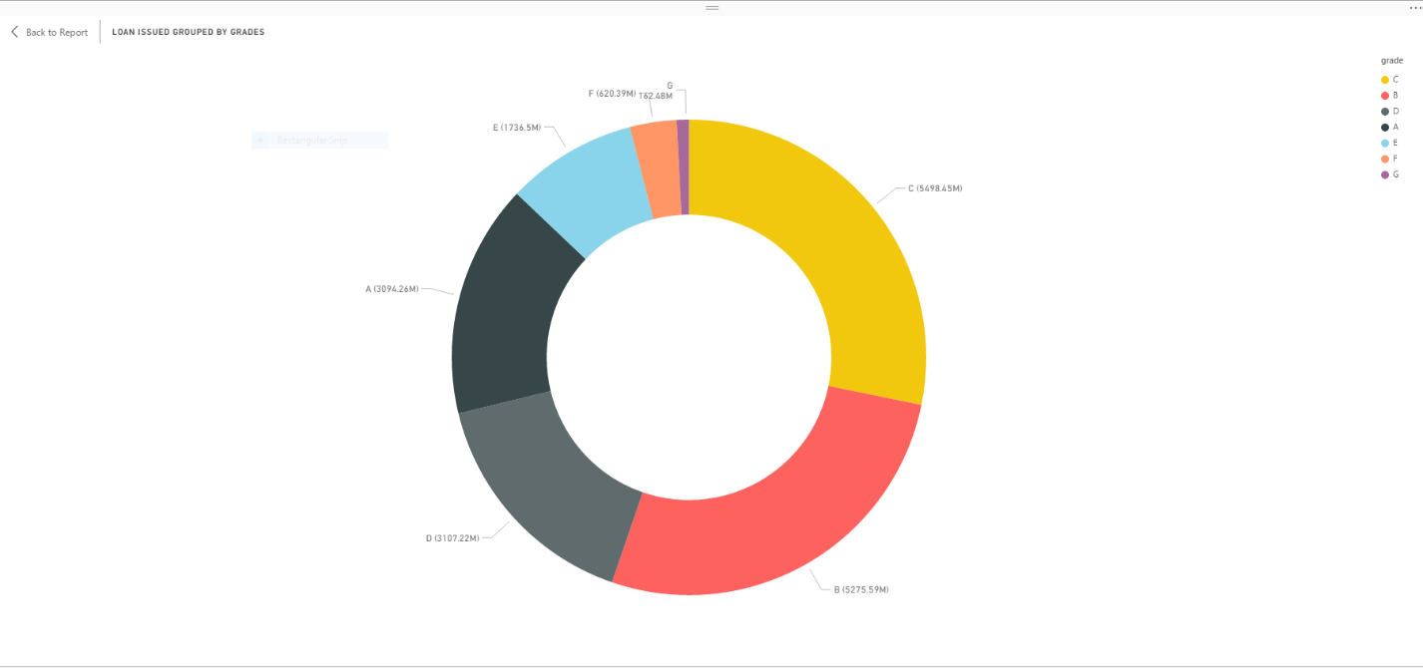

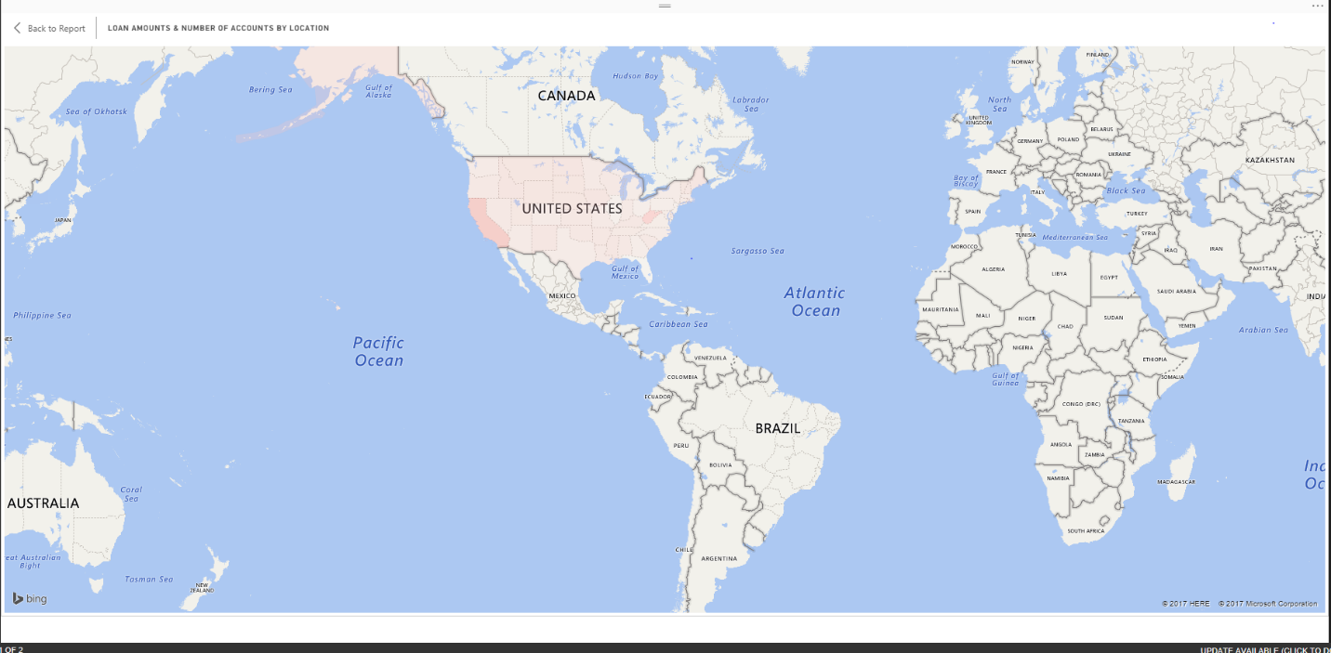

Donut -Loan Issues grouped by home ownership

Does home ownership have any relationship with Credit scores and Charge Off rates

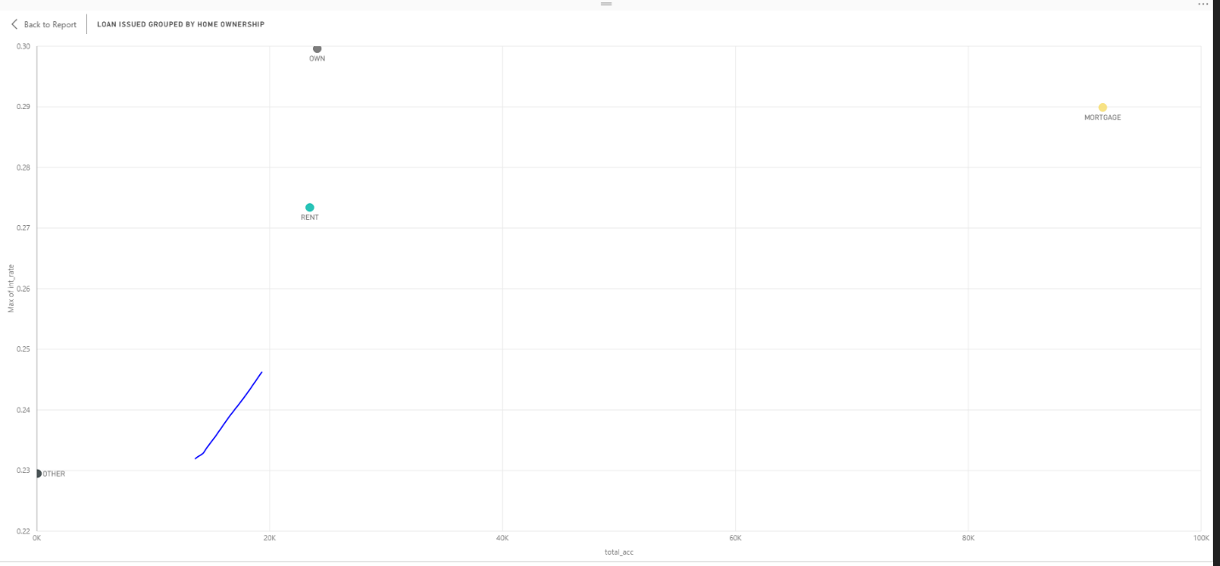

Loan Issued group by purpose

We want to see if there is any relation between credit scores, Charged rates and purpose. There is a strong correlation between charge off rates and if the purpose is either **educational** or **small business**. These loans tend to be a lot riskier.

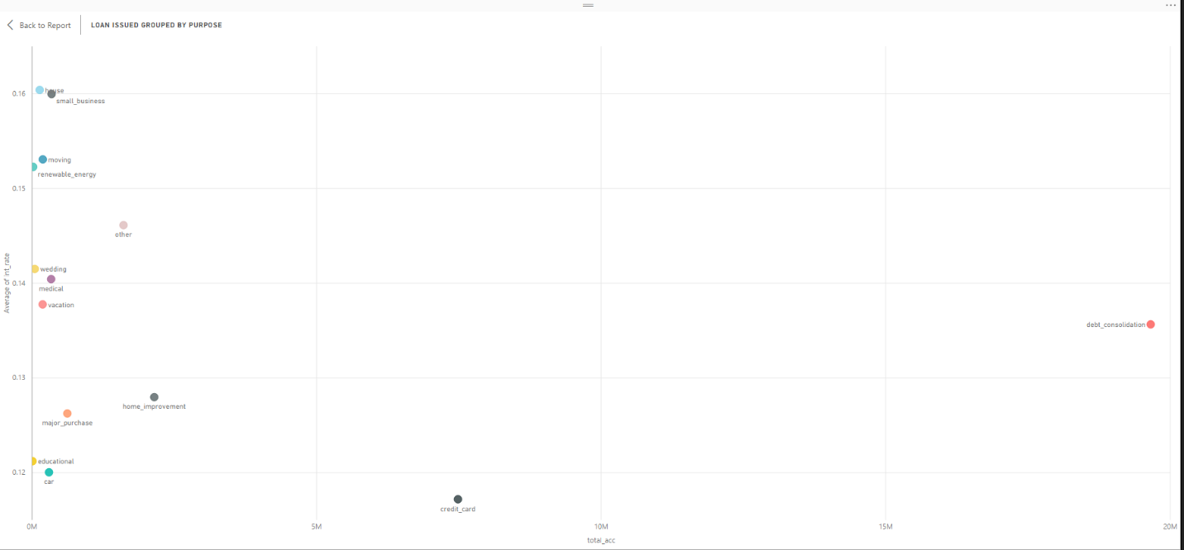

Summary Matrix summarising Employment length that & average of annual incomesare actually the features with the least obvious link to default rates:

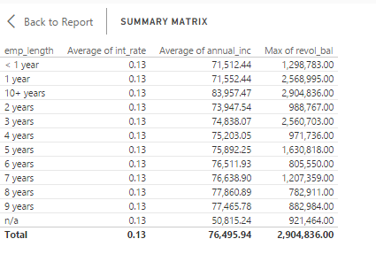

Debt to Income Ratio & Installment lengths

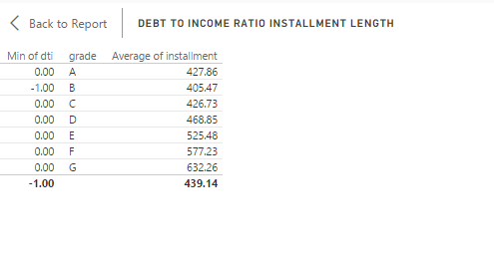

Credit Age vs Loan Status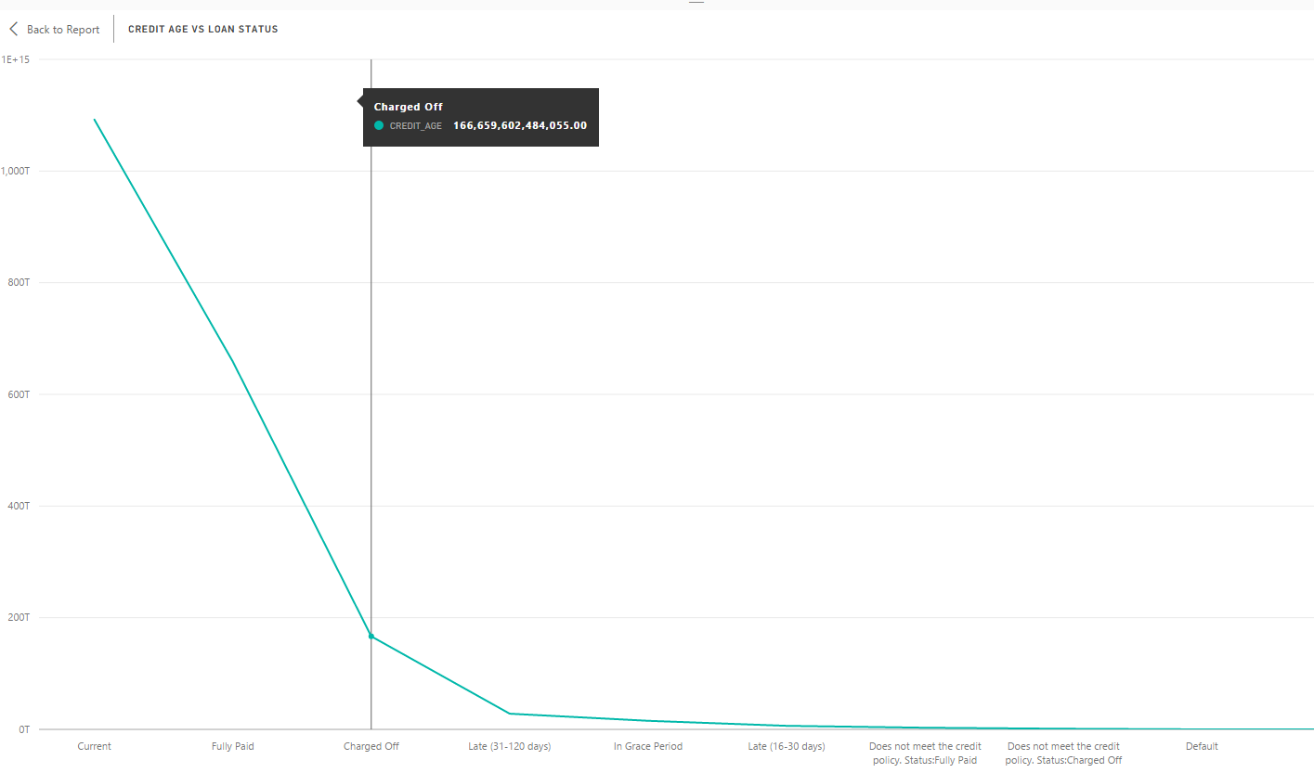

Credit age vs Loan Status



Rejected Data Dashboard

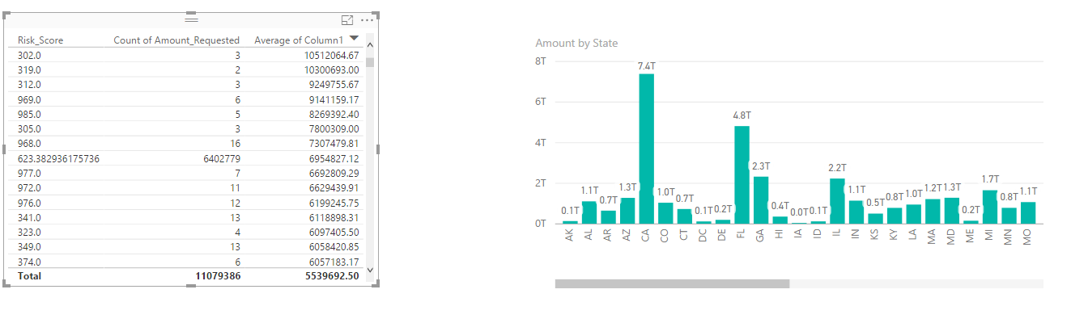

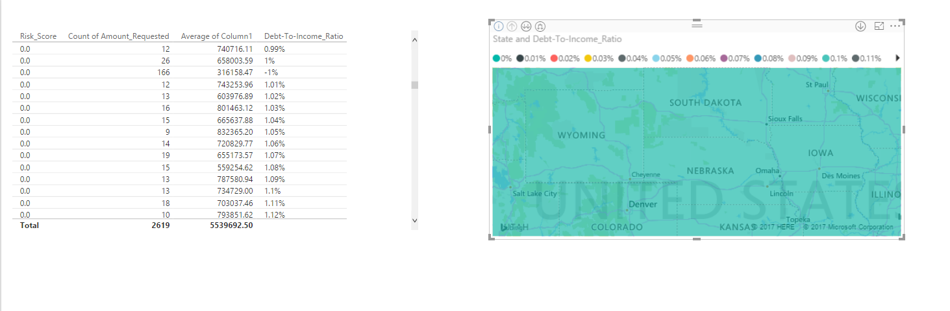

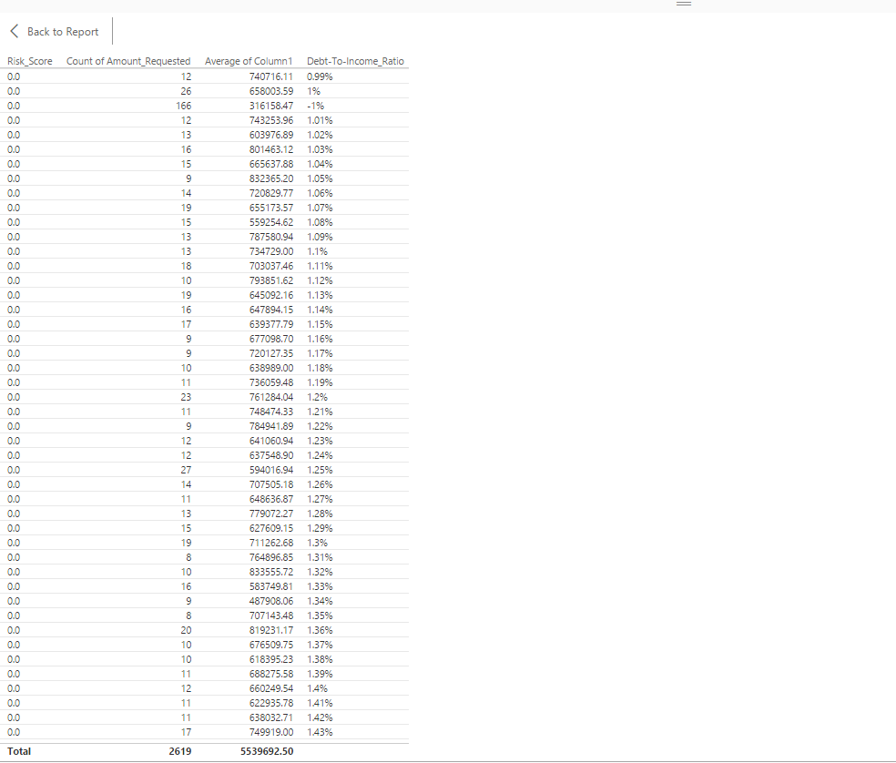

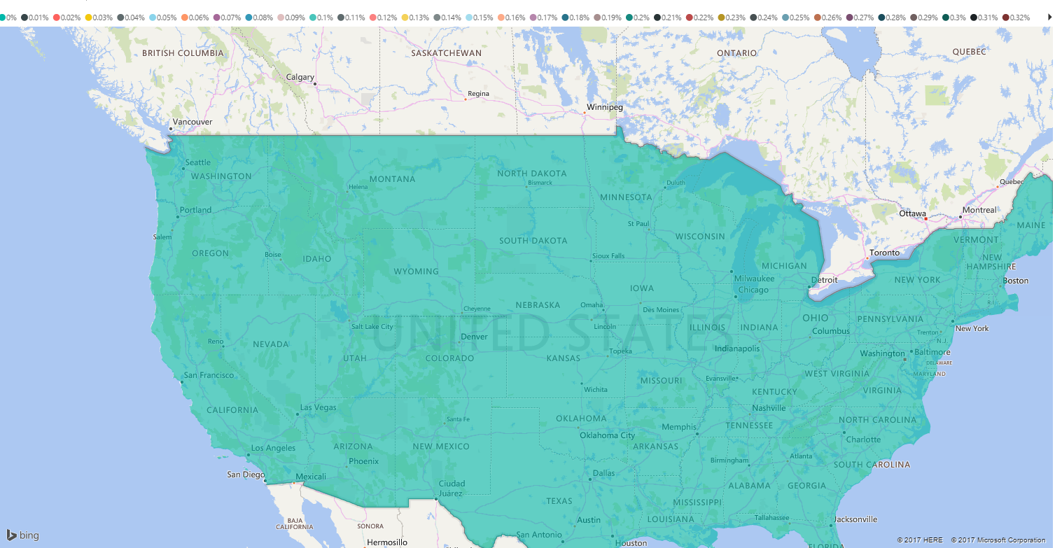

**Pipeline with Luigi (Accepted loan dataset):**

Pipelined tasks, data extraction, missing value handling and data exploration using luigi **for accepted loan data set**

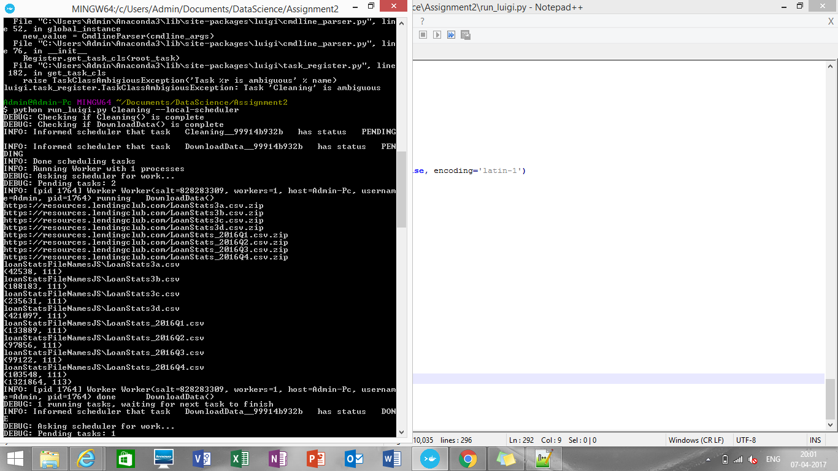

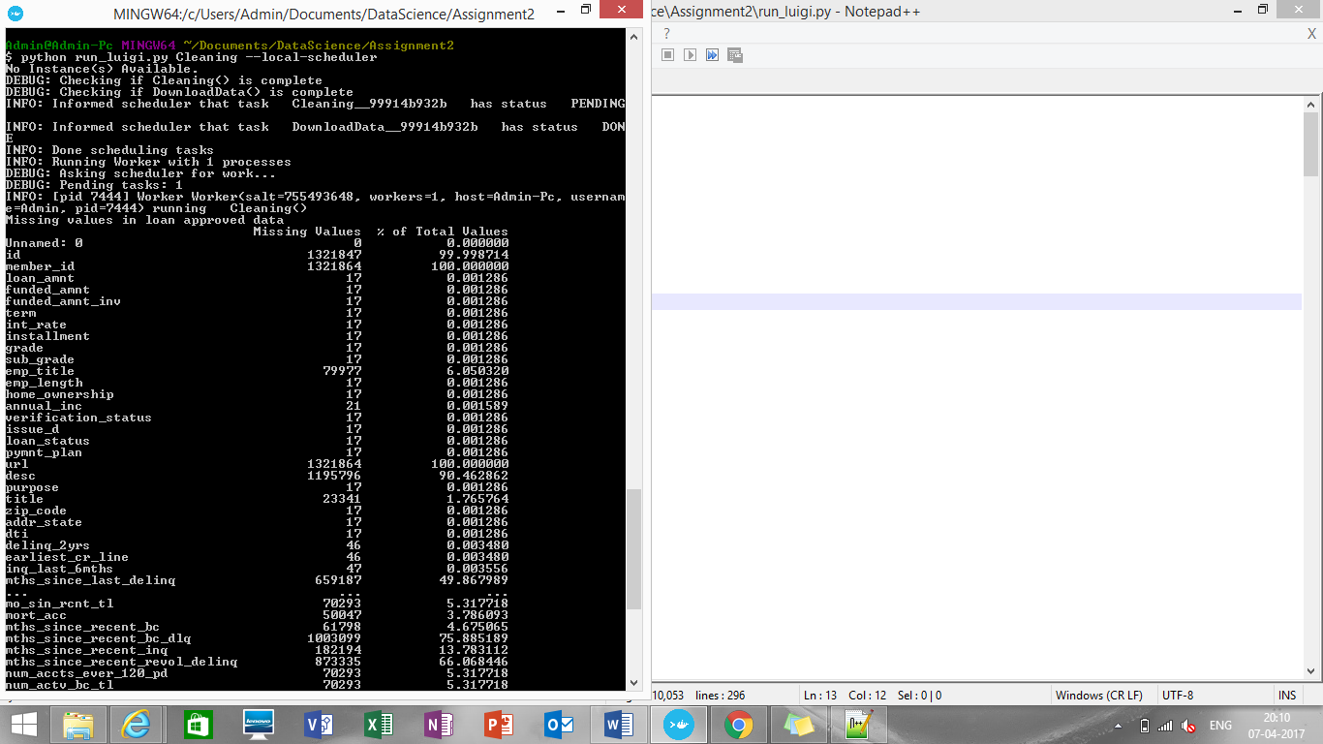

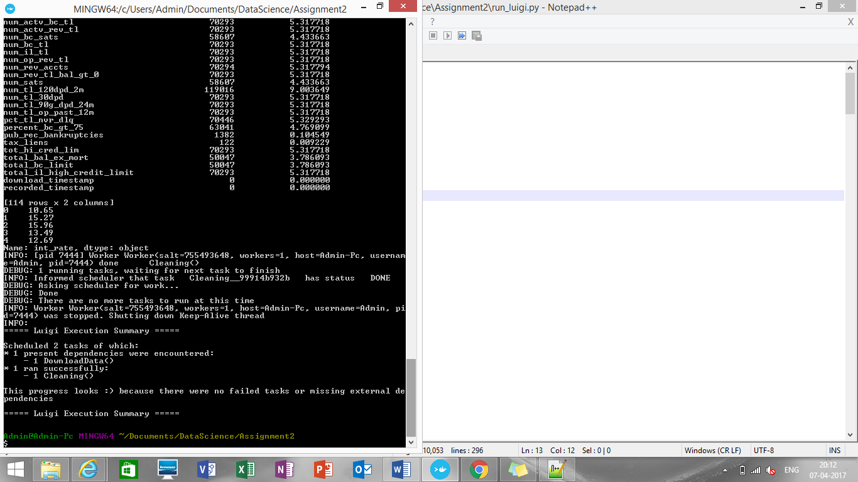

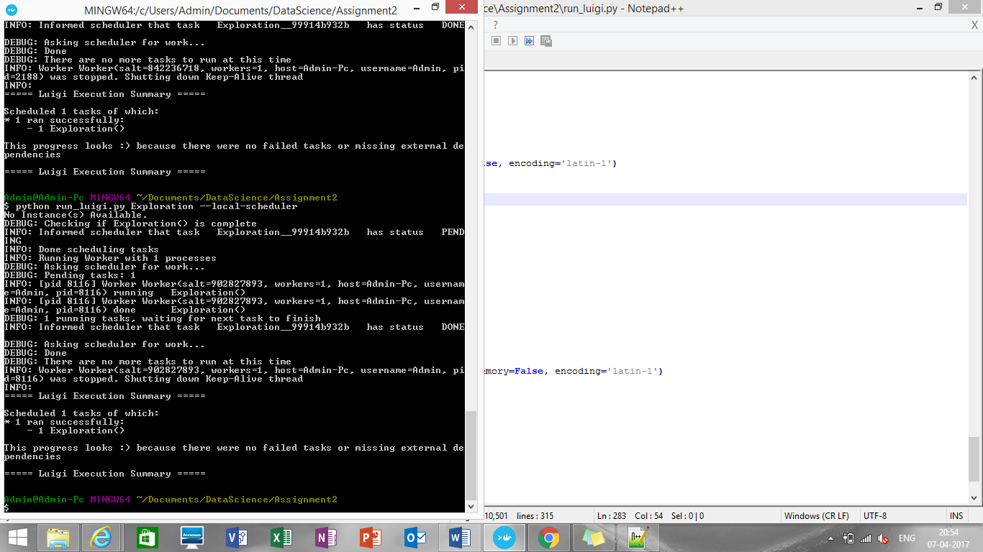

**Pipeline with Luigi (Declined loan dataset):**

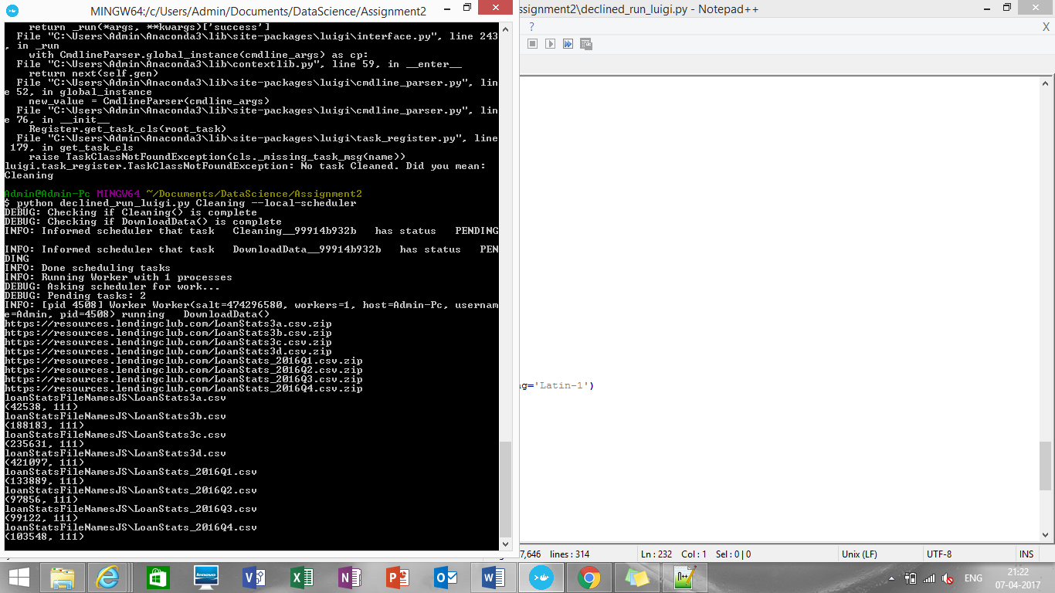

**Pipeline with Luigi (Rejected loan dataset):**

Same steps are implemented for declined_run_luigi.py

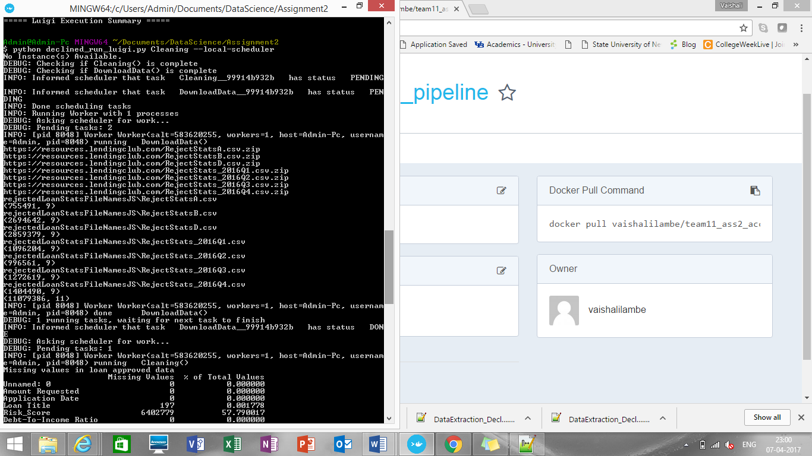

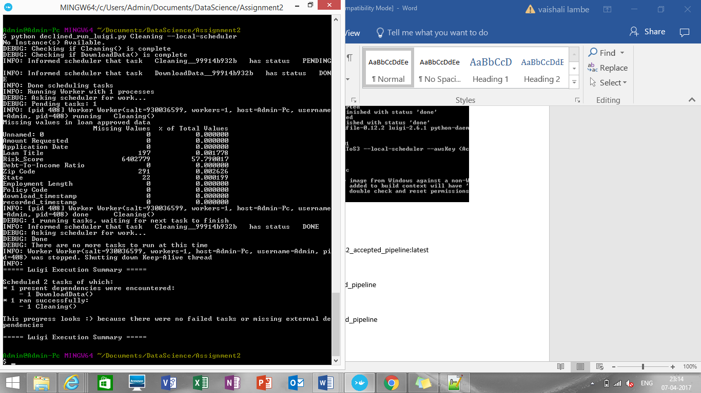

**Dockerization:**

**Building image for accepted loan data pipeline**

pushd C:/Users/Admin/Documents/DataScience/Assignment2/pipeline

docker build -t part1_accepted .

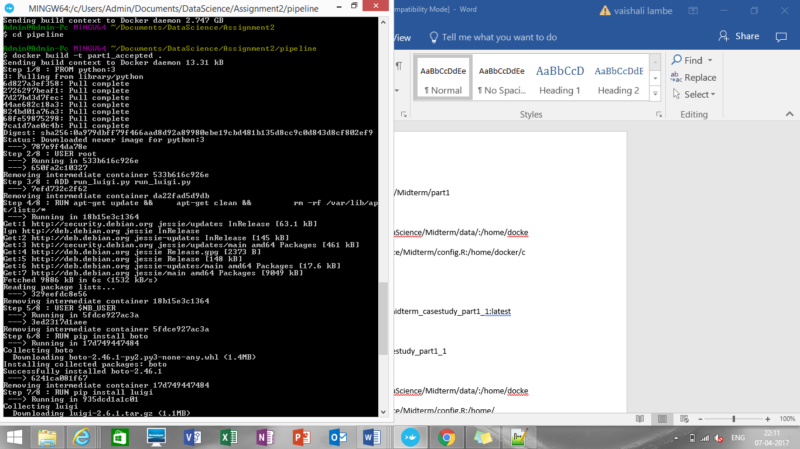

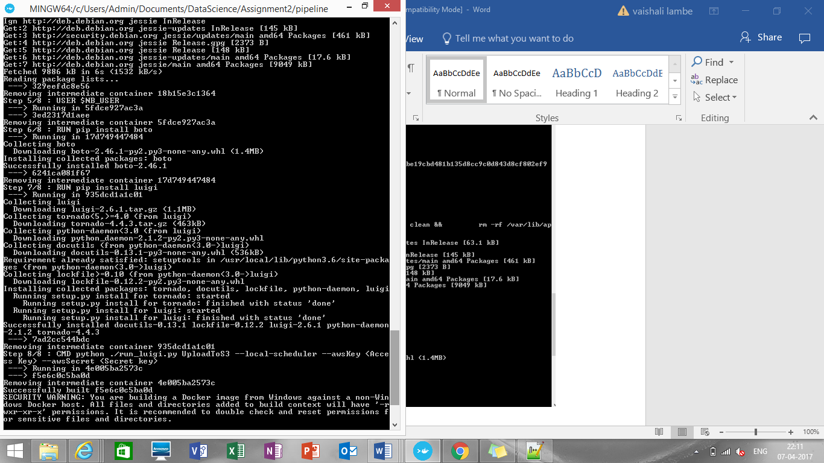

docker images

docker tag <IMAGE ID> [vaishalilambe](https://hub.docker.com/u/vaishalilambe/)/[team11_ass2_accepted_pipeline](https://hub.docker.com/r/vaishalilambe/team11_ass2_accepted_pipeline/):latest

docker login

docker push [vaishalilambe](https://hub.docker.com/u/vaishalilambe/)/[team11_ass2_accepted_pipeline](https://hub.docker.com/r/vaishalilambe/team11_ass2_accepted_pipeline/)

**To run the image**

$ docker run [vaishalilambe](https://hub.docker.com/u/vaishalilambe/)/[team11_ass2_accepted_pipeline](https://hub.docker.com/r/vaishalilambe/team11_ass2_accepted_pipeline/)

**Contribution Pie Chart:**

Tasks done Vaishali: Accepted loan data, extraction, missing data handling, exploration, Dockerization, pipeline luigi (both accepted and decline data), report preparation, docker commands, github upload

Tasks done Rijuta: Rejected loan data, extraction, missing data handling, exploration, report documentation

Tasks done Ankur: PoweBI analysis for accepted and rejected data, report documentation for powerBI